Machine Learning Based Disambiguation of Author’s Names in ORCID Citations

## Abstract

Author’s Names Disambiguation(AD) is a type of record linkage which is applied to scholarly documents. The ambiguity often occurs due to different factors such as authors who have more than one name version, or group of authors who share the same name. Therein, it is difficult to distinguish between scholarly document authors or to group scholarly documents by authors. Machine learning techniques provide a solution to deal with this challenge by training the machine to classify all the documents belonging to a certain author and distinguish them from works of other authors sharing the same name. However, AD is still a great challenge due to the ever-increasing size of digital libraries and the lack of training examples that represent the whole domain. This study aims at providing a solution by using ORCID citations as a large and reliable source of training data. A comparison study has been made among a group of machine learning approaches including j48, DNN, Naive Bayesian and Random forest. The results from the experiment have proven that Random forest classifier is the best among them with almost 95% accuracy. In addition, coauthors feature was the most important instance compared to the other instances which has an impact of 12.9% in eliminating ambiguity in author’s names.

# Contents

#### List of Tablesx List of Figuresxi

1. **Introduction****1**
   1. Problem Statement and Motivation. . . . . . . . . . . . . . . . . . . . . . . . 1 1.2 Definitions. . . . . . . . . . . . . . . . . . . . . . . . . . . . . . . . . . . . . 3 1.3 Thesis Structure. . . . . . . . . . . . . . . . . . . . . . . . . . . . . . . . . . 4

#### Background5

2.1 ORCID Structure. . . . . . . . . . . . . . . . . . . . . . . . . . . . . . . . . 5

* 1. Introduction to Weka 10
     1. Using Weka 11
  2. Random Forest Classification 12
     1. RF Parameters 13
  3. Machine Learning Performance Evaluation 13
     1. Information Gain (InfoGain) 14
     2. Cross Validation for Classification Problems 14
     3. Model Evaluation Metrics 14
        1. Metrics Computed from a Confusion Matrix 15
        2. Receiver Operating Characteristic Curve (ROC) 17
        3. Area Under the Curve (AUC) 17
  4. Semantic and Distance Matrices 18
     1. Semantics 18
     2. Levenshtein Distance 20
     3. Damerau Levenshtein Distance 21
     4. Jaro Similarity 21
     5. Jaccard Similarity 21
     6. Cosine Similarity 22
     7. N-Grams Similarity 23
     8. Optimal String Alignment 23

1. Literature Review25
   1. Type of Approach 25
      1. Author Grouping Methods 25
      2. Unsupervised Techniques 26
      3. Supervised Techniques 26
   2. Database 26
   3. Features Information 26
   4. Experiments Evaluation 28
      1. The Mean and Standard Deviation 28
      2. Experiments Design and Evaluation 28
   5. Related works 28
2. Methodology and Data Analyses31
   1. ORCID Database 31
      1. Datasets Selection 31
      2. Database and Labeling 32
   2. Methodology 33
      1. Design Rules 33
         1. Notes on ORCID Profile 33
         2. Citation Representation 34
      2. Coauthor Methodology 38
      3. Publishing Year Methodology 41
      4. Journal Title Methodology 41
      5. Work Title Methodology 42
      6. Machine Learning 44
   3. Chapter Summary 45
3. Experiments and Results47
   1. Experiments Setup 47
   2. Random Forest Classifier 48
      1. RF statistic Result 49
   3. Random forest versus other machine learning approaches 50
   4. Features Ranking and Distance Matrices 51
   5. Execution Time 54
4. Conclusion and Future Work57
   1. Conclusion 57
   2. Future Work 58

#### A Web-Application59 Bibliography75

2.1 Confusion matrix (C.M) 15

* 1. Outline of Disambiguation Procedures 27
  2. Outline of Disambiguation Performance 30
  3. Orcid Datasets Samples 32
  4. Training and Testing samples 33
  5. RF tuned parameters using 10-folds cross validation 48
  6. The statistics results in the testing phase 49
  7. RF detailed accuracy results in testing phase 49
  8. Analysis of algorithm on Knowledge level ORCID Data set 50
  9. Detailed Accuracy by Class 51
  10. Features Ranking and Distance Matrices 52
  11. Features Ranking and Distance Matrices by excluding the two smallest InfoGain values 53
  12. The statistics results in the testing phase 54
  13. RF detailed accuracy results in testing phase 54
  14. Pre-processing time performance 55

1.1 Name Disambiguation. . . . . . . . . . . . . . . . . . . . . . . . . . . . . . . . 2

2.1 Author profile [](#_bookmark15)[1](#_bookmark172)[]. . . . . . . . . . . . . . . . . . . . . . . . . . . . . . . . . . . 5

2.2 ORCID record structure. . . . . . . . . . . . . . . . . . . . . . . . . . . . . . . . 7

2.3 ORCID-work activities. . . . . . . . . . . . . . . . . . . . . . . . . . . . . . . . 8

2.4 Public ORCID ID. . . . . . . . . . . . . . . . . . . . . . . . . . . . . . . . . . . 9

* 1. Weka GUI Chooser 11
  2. Weka Explorer 12
  3. ROC Curve and AUC 17
  4. Similarity Measures, bold are the ones that we used 18
  5. Levenshtein distance 20
  6. Cosine distance 22
  7. N-Grams overlapping 23
  8. Citation Architecture 34
  9. Positive pairs for separated citations from an author’s profile 35
  10. Positive pairs for one author profile (Chain of citations) 35
  11. Negative pairs (First Method) 36
  12. Negative pairs (Second Method) 37
  13. Coauthor’s Names Structure 39
  14. Journal Similarity 42
  15. Sentence similarity computation diagram 44
  16. Machine Learning Phases 45
  17. Weka Classification 45
  18. The Methodology Phases 46
  19. ROC curve for predicting the author’s citation pairs. 50
  20. Comparison between machine learning approaches (ROC Curve) 51
  21. Accuracy value by excluding one feature periodically 53
  22. Accuracy value by excluding one feature periodically according to InfoGain ranking results 54
  23. Time performance in pre-processing phase 55

*List of Figures*

* 1. Time performance prediction using RF classifier 56
  2. Matching and not matching web-application process 59
  3. ML Based Disambiguation of Author’s Names in ORCID Citations Application 74

# Glossary

**A.C.C** Author’s Citation.3

**AC** Author’s Contribution.3

**AD** Author’s Names Disambiguation.vii,1,3,25,26,31,33,44,55

**AM** Author’s Match.4

**AN** Author’s no-match.4

**AUC** Area Under Curve.47

**C.M** Confusion matrix.14

**CA** Classification Accuracy.15 **CE** Classification Error.15 **CM** Citation Matching.3

**DL** digital library.2

**DM** Distance Matrices.51,52

**DNN** Deep Neural Networks.47

**F***num* The number of features to consider when splitting each node.13

**FPR** False Positive Rate.50

**J48** Decision Tree.47

**LNFI** Last-name First-intial.4

**MC** Mixed Citation.4

**Orcid ID** Author’s Identifiers.3

*GLOSSARY*

**RF** Random Forest.12,13,47

**ROC** Receiver Operating Characteristic.17

**SC** Split Citation.4

**T***depth* The tree depth.13 **T***num* total number of trees.13 **TPR** True Positive Rate.50

**Weka** Waikato Environment for Knowledge Analysis.10

# Chapter 1 Introduction

The quantity of scholarly documents is growing rapidly. Different authors may share the same name and may also publish under various names. This may lead to inconsistency in publications data where publications of some authors be placed under different authors. For the researchers in their fields, it is important to find all working activities of the same author and cluster them together. Our objective in this thesis is to introduce a solution to disambiguate the authors’ names.

## Problem Statement and Motivation

Author’s Names Disambiguation(AD) is a very important and complex research topic. During search and retrieval of information there is a shortage in results because of the great potential of authors who share the same name which negatively influence the scientific research life cycle. Therefore, it is necessary to find a reasonable and effective way to distinguish the different authors who share the same name and thereby, identify the identity of each author.

Disambiguation of author’s names can enhance the scientific discovery process and improve the efficiency of research funding and collaboration within the research community. It is important to clarify the ambiguity in the authors’ names as a mean of gathering their research work, make their research known, increase the chance of citation, ensure that the research is counted in research assessment and to increase the chance of new collaboration. AD helps authors to have complete profiles containing all their work which increases the accuracy and reliability to distinguish and cluster their works.

AD is a challenging problem that is caused by multiple reasons. Among which, authors may publish under multiple names for variety of reasons including different spelling, misspelling, name change due to marriage, or the use of the family names and initials. Figure1.1illustrates a case ofADproblem. In the upper half of the figure, four different authors’ share the same name "Mohammad Imran" while, in the lower half, the same author has four different names: The first name then the family name, the first initial of the first name then the family name, the family name followed by the first initial of the given name and finally, the family name followed by the

first name.

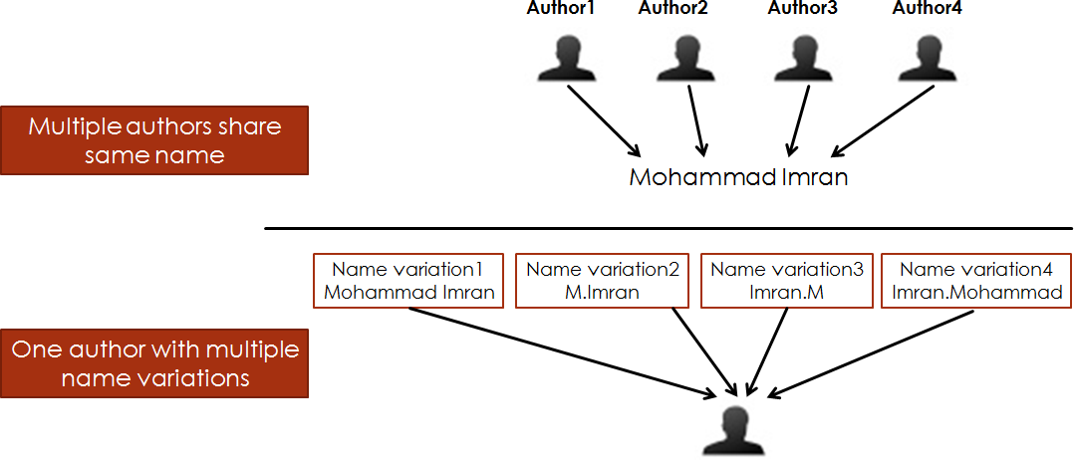

Figure 1.1: Name Disambiguation

Typical approaches for AD rely on information about the authors such as their affiliations, email addresses, year of publication, co-authors and other topic information to distinguish authors. Data that comes from individuals and organizations seems to be a hybrid system where all who participate in research, scholarship, and collaborations are uniquely identified and connected to their contributions and affiliations. In short, with a hybrid system designed to accommodate records from multiple sources, how do we determine that citation *X* record from *Y* different sources are likely to be referring to the desired researcher. These information can be used in machine learning approaches to decide whether two papers refer to the same author or not.

In recent years, the collection of bibliographic information relevant to a particular article has become a major challenge [2]. Users often need to exploit the relationships between citations to determine the impact of a particular articledigital library(DL) 3[]. In order to keep the citations of stored documents in DLs, consistent and up-to-date, we must keep in mind the excellent description of the four main challenges that impact name disambiguation that have been offered

by (Smalheiser & Torvik, 2009) [4]

* + 1. The name abbreviations that consist of the initial letter or parts of the first name, middle name and family name, are included in the articles database instead of the full-name.
    2. Identical names in which multiple authors may share the same name label. 3.The same individual might write more than one name due to:
       - Spelling errors.
       - Name changes (for marriage, religious conversion, etc.).
       - Spelling variants.
       - The use of pen names.

4.Pseudonyms or alias that someone such as an author uses instead of his or her real name.

The Open Researcher and Contributor ID (ORCID) registry presents a unique opportunity to solve the problem of author names ambiguity [9]. From ORCID organization perspective, creating identifiers for individual researchers means creating a system where there is a one-to-one relationship between the identifier and the researcher. But every researcher could apply for ORCID identifier several times, this may mean many identifiers for the same author, uncompleted profile and that the author might write his name in different forms. Therefore, ORCID is not enough to solve the ambiguity of authors’ names. ORCID mission statement implies that its system has the ability to generate a unique identifier for each author registered in the system. The questions about how each author profile records are created, how they are managed and corrected and who owns them are of a very importance and need to be resolved well before any public ORCID system is built and launched.

In this work we propose a new method to solve theADproblem using supervised machine learning. Like some existing literature, we re-define the AD problem as a binary classification problem. The classification system in our case reads the meta data of two authors and maps them to the *similar* class or to the *notsimilar* class. Also, we construct a web-application to predict wither two citations belong to same class or not as illustrated in appendix A.

Researchers who follow this approach has the challenge of collecting and labeling data for training the classifier. Our approach in this thesis is to make use of ORCID data for training since it represents a pre-labeled and representative dataset. This enabling us to build an accurate and reliable machine learning model that can produce a solution for the ambiguity problem in the names of authors without the effort needed to collect and label new data. ORCID contains citation data, each citation consists of the basic attributes namely, "coauthors names, journal title, work title and the publishing years".

## Definitions

Below are the definitions and the acronyms that have been used through the thesis:

* + 1. Author’s Identifiers(Orcid ID): ORCID system provides a unique 16 digit identifier to authors’.
    2. Orcid-profile : Each author has one profile with only one ORCID ID.
    3. Author’s Contribution(AC): The author’s work information consist of Author’s Affiliation (AF) andAuthor’s Citation(A.C.C). AF or the name of the institution where the author work, consists of the organization name and the department name; while A.C.C contains the citation information.
    4. Citation Matching(CM): Given two sets of publications *X* and *Y* , in order to find for each

*xsX* a set of *y*1*, y*2*, y*3*, ..yn, sY* such that both *x* and *yi* (1 *≤ i ≤ n*) belong to the same

author. Because of the lack of fixed format for citations, various names may be attributed to a single author.

* + 1. Mixed Citation(MC): Given a collection of publications *X*, by an author *A*1, our goal is to identify publications by another author *A*2 in *X*, when *A*1 and *A*2 share the same name string [5].
    2. Split Citation(SC): Given two sets *X* and *Y* of author’s names and associated publi- cations, the challenge is to find each author’s name *xsX* in a set of author’s names, *y*1*, y*2*, y*3*, ..yn, sY* such that both *x* and *yi* (1 *≤ i ≤ n*) are names variants of the same author. [6].
    3. Last-name First-intial(LNFI): The author’s string name established from the first initial of the given name and the family name (e.g. Wang, Y).
    4. LNFI Cluster: In which a group of authors share the same last-name first-initial, e.g., there are 829 Zhang,Y authors share LNFI.
    5. Author’s Match(AM): Two or more ACs that refer to the same individual. 10.Author’s no-match(AN): Two ACs that refer to different individuals.

## Thesis Structure

The remaining parts of this thesis are organized as follows: Chapter 2 presents the background for this thesis with a detailed description of the ORCID data structure, machine learning, performance evaluation techniques and the distance matrices. Chapter 3 discusses research related of this work. Chapter 4 contains the methodology and data analyses. It presents the process of selecting the ORCID data-sets, feature representations used by machine learning algorithms, and the general methodology used by the machine learning methods in predicting new citations records. Chapter 5 shows the experiments done to predict new citation pairs, random forest versus other machine learning approaches, and the results obtained from these experiments. Chapter 6 contains conclusion and future work. It summarizes the work done in this thesis.

# Chapter 2 Background

## ORCID Structure

ORCID is a non-profit organization, whose aim is to solve the author’s name ambiguity problem in scholarly communications by creating unique identifiers (ORCID ID) for individual researchers and supports linkages between each author and his professional activities as illustrated in Figure2.1. By using ORCID ID, ORCID ensures that all researchers activities and outputs are easily discoverable [7]. ORCID membership is opened to any organization interested in

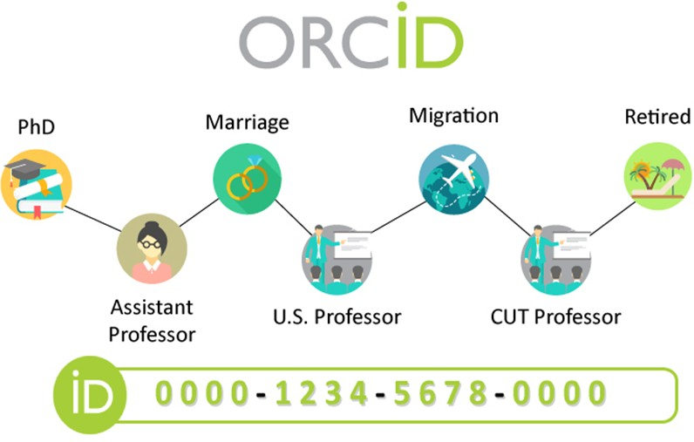

Figure 2.1: Author profile [1]

integrating ORCID identifiers [8]. ORCID database records are created by individuals to whom the records refers, in which we can share information for both public and registered members to support open access to information for the research community. Figure2.2illustrates ORCID records structure which consists of:

* + 1. Root element: The content of the researcher data is added within the root element.
    2. ORCID identifiers (ORCID ID): ORCID system provides a unique sixteen digit identifier to each person, e.g. 0000-0002-4210-6896.
    3. Language preference: English is the default language, but it can be changed into the user’s preference.

*Chapter 2. Background*

* + 1. History details: This part shows how the ORCID record was created. It can be either "website" or "direct". When the record was created through the ORCID registry directly, "member-referred", when a member sent a user to the Registry and the sign up was done as part of an author’s connection and "API" when it was created with a batch create process on behalf of the user.
    2. Biographical information: Both personal and biographical information are included under ORCID-bio, available under ORCID-profile. It contains: Personal-details, biography, external website links, contact-details, keywords and external identifiers.
    3. ORCID Activities: It comes after the biographical information. It includes the affiliations, works and/or funding items. The affiliation section of an ORCID record is recorded under ORCID-activities. This area is separated from the ORCID-bio fields. Affiliation includes many fields as described in Figure2.2. Works information which includes the author’s activity work as illustrated in Figure2.3
    4. Source: Contains information about how and when the elements were added to the record. The elements are: ORCID-history, external-identifier, affiliation, ORCID-work and funding.
    5. Create-Date: The date and time when the element was created.
    6. Last modified date: The date and time when the record was last modified.

*Chapter 2. Background*

7

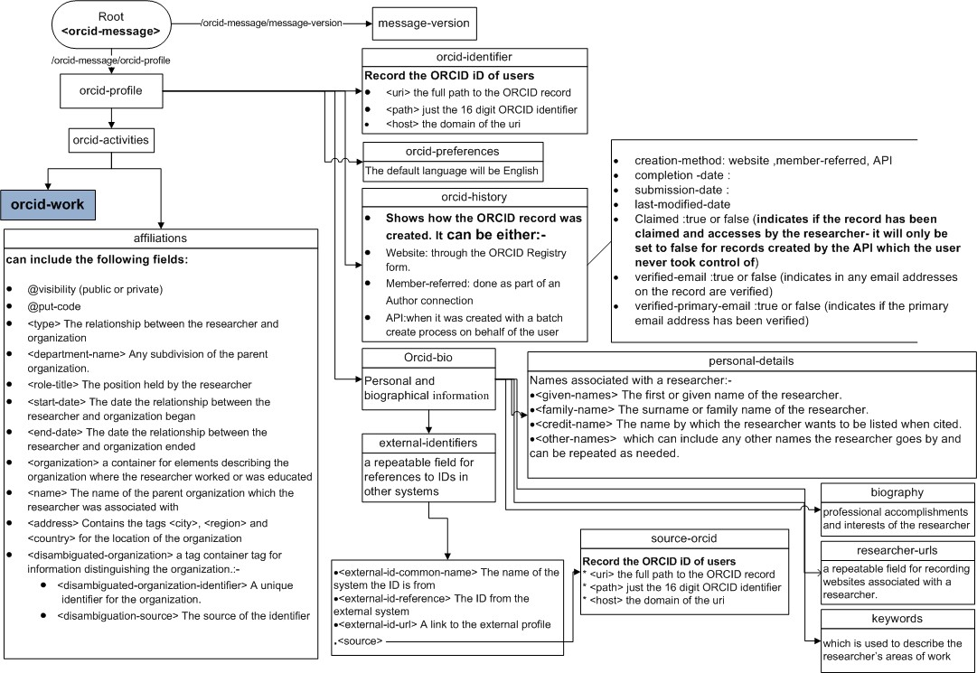

Figure 2.2: ORCID record structure

*Chapter 2. Background*

8

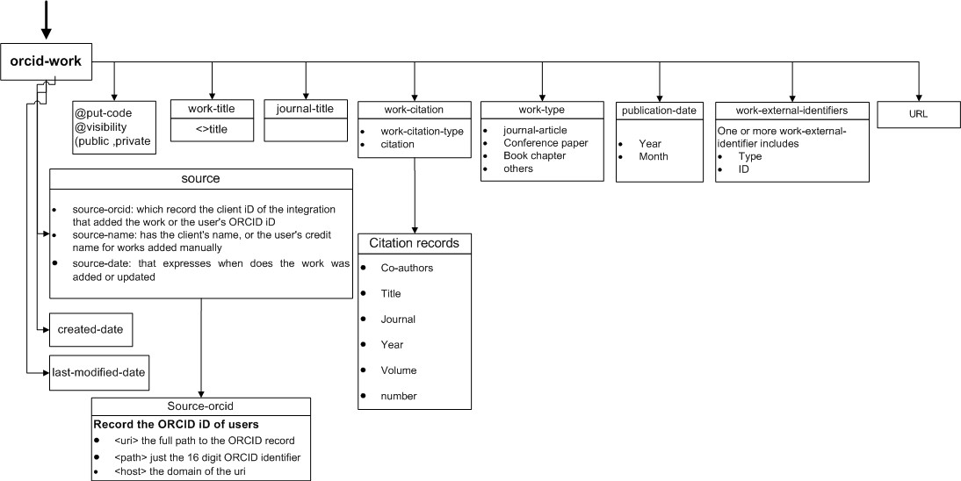

Figure 2.3: ORCID-work activities

In order to effectively identify and achieve this mission, ORCID needs to be a part of several publisher work-flows:

Firstly, *manuscript submission system* where ORCID identifier can be collected when an author submitting the basic information such as publication title, author’s name, affiliation, abstract, cover letter, etc, then journals could ask coauthors to enter their ORCID identifiers.

Secondly, *searching for prior work* by linking author’s name with ORCID identifier as illustrated in Figure2.4. This will be used as a public ORCID ID to eliminate the ambiguity of searching taking into account the strategies of ORCID registration process as follows:

1. Non-active researchers could apply for ORCID identifiers several times.
2. The system would depend on a third-parties to provide organizationally-asserted records.
3. Control over profile information will determine that citation X from Y different sources refers to the desired researcher.



Figure 2.4: Public ORCID ID

Name ambiguity can exists clearly when the author’s name is introduced by first-name initial and last-name. For example, different names Sung Jin Kim and Seon-Kyu Kim are simplified to the same name label S Kim [9]. In ORCID database, the string name "Wang Y" has various name variations, e.g, "Wang Ying", "Wang Ying Yang" and "Wang Lee Yung". As well in the web DBLP [10], the author page of "Yu Chen" contains citations from three different people with the same name: "Yu Chen" from University of California Los Angeles, "Yu Chen" from Microsoft at Beijing branch, and "Yu Chen" as the senior professor from Renmin University of China. This problem is identified as a situation where multi authors’ share the same name label. According to Smalheiser and Torvik, in ORCID files authors can be identified by the first initials only, by the middle name included with the family name, or by the family name only instead of the full name. Because of the growing orientation of different science approaches, it has become more difficult to tell whether John Smith publishing about linguistics is different from John Smith publishing in biochemistry, whereas in the past, two identities could be safely

assumed. [4].

Therefore, it is not practical to manually create a profile for each author due to the presence of huge digital libraries. In other words, automatic name disambiguation project should consider all different cases to help others using data in term of performance, accuracy and availability.

## Introduction to Weka

Weka is a collection of machine learning algorithms and data pre-processing tools. It is designed in a flexible ways so that you can try out existing methods on new and unseen datasets. It provides large-scale support for the whole process of experiments, including preparing the input data, evaluating learning schemes statistically, and visualizing the input data and the result of learning. As well as a wide variety of learning algorithms, it includes a wide range of pre-processing tools. This diverse and comprehensive toolkit is accessed through a common interface so that its users can compare different methods and identify those that are the most appropriate for the problem at hand.

Waikato Environment for Knowledge Analysis(Weka), is a Java based open-source data mining tool developed by the University of Waikato. In recent years, Weka has also been implemented in Big Data technologies such as Hadoop [11]. The system is written in Java and distributed under the terms of the GNU General Public License. It runs on almost any platform and has been tested under Linux, Windows, and Macintosh operating systems. It provides a uniform interface to many different learning algorithms, along with methods for pre-processing, post-processing and for evaluating the result of learning schemes on any given dataset.

Weka provides implementations of learning algorithms that you can easily apply to your dataset. You can pre-process a dataset, feed it into a learning scheme, and analyze the resulting classifier and its performance without writing any program code at all. The workbench includes methods for all the standard data mining problems: regression, classification, clustering, associa- tion rule mining, and attribute selection. Getting to know the data is an integral part of the work, and many data visualization facilities and data pre-processing tools are provided. All algorithms take their input in the form of a single relational table in the ARFF format, which can be read from a file or generated by a database query.

One way of using Weka is to apply a learning method to a dataset and analyze its output to learn more about the data. Another one is to use learned models to generate predictions on new instances. A third one is to apply several different learners and compare their performance in order to choose one for prediction. The learning methods are called classifiers, and in the interactive Weka interface you select the one you want from a menu. Many classifiers have tunable parameters, which you access through a property sheet or object editor. A common evaluation module is used to measure the performance of all classifiers. Implementations of actual learning schemes are the most valuable resource that Weka provides. But tools for pre- processing the data, called filters, come a close second. Like classifiers, you select filters from a menu and tailor them to your requirements. Weka also includes implementations of algorithms for learning association rules, clustering data for which no class value is specified, and selecting relevant attributes in the data [12].

### 2.2.1 Using Weka

When you start up Weka you have to choose among four different user interfaces: the *Explorer*, the *Knowledge Flow*, the *Experimenter*, and the *command-line* interface as shown in Figure2.5.



Figure 2.5: Weka GUI Chooser

The easiest way to use Weka is through a graphical user interface called the *Explorer* as illustrated in Figure2.6. This gives access to all of its facilities using menu selection and form filling. The *Explorer* interface presents choices as menus, buttons, text-boxes, presenting options as forms to be filled out. Helpful tool tips pop up as the mouse passes over items on the screen to explain what they do.

There are two other graphical user interfaces supported by Weka. The *Knowledge Flow* interface allows you to design configurations for streamed data processing. The *Knowledge Flow* interface lets you drag boxes representing learning algorithms and data sources around the screen and join them together into the configuration you want. It enables you to specify a data stream by connecting components representing data sources, pre-processing tools, learning algorithms, evaluation methods, and visualization modules. Weka’s third interface, the *Experimenter*, is designed to help you answer a basic practical question when applying classification and regression techniques. Behind these interactive interfaces lies the basic functionality of Weka. This can be accessed in raw form by entering textual commands, which gives access to all features of the system [12].

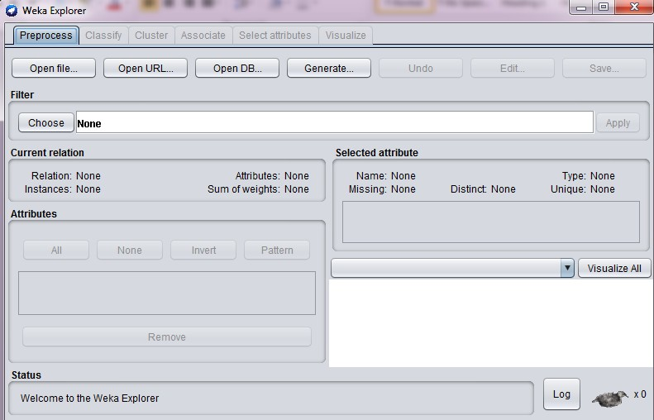

Figure 2.6: Weka Explorer

## Random Forest Classification

Random Forest(RF) classification is one type of machine learning approaches. It belongs to the ensemble learning algorithm which received increasing interest because they are more accurate and robust to noise than single classifiers [13]. Ensemble algorithms are those which combine more than one algorithm of the same or different kinds for classifying objects.

RFwas proposed by Breiman and presents many advantages.RFalgorithm is a supervised machine learning algorithm which is capable of performing both regression and classification tasks. It also handles the missing values and maintains accuracy for missing data. Besides, it has the power to handle large data set with higher dimensionality. Moreover, it does not allow overfit the model and runs efficiently on large database. It estimates the important variables in the classification and generates an internal unbiased estimate of the generalization error (Out-of-bag error). Finally, it computes proximities between pairs of cases used in locating outliers and is relatively robust to outliers and noise. On the other hand, Breiman underlined some disadvantages of theRF. First of all, it does good job at regression but not as good as for classification. Secondly, the control the user has is very minimized on the model and it is like a black box approach for statistical models [13].

InRF, we create multiple decision trees *h*(*X,* Θ*k*), where *h*(Θ*k*) are the random vectors

which are distributed identically and X is the variable to be classified. For constructing the *k* trees, RF first generates k random vectors *h*(Θ1*,* Θ2*, ..,* Θ*k*) which are independent of each other and of the same distribution. Each tree provides a classification based on the given training samples and random vectors Θ*i* where *is*[1*, k*] . RF saves the tree votes for specific class and it chooses the classification based on the majority of votes over all the other trees in the forest.

Equation2.1calculates the voting model of RF 14[].

*HR*(*X*) = *max*

*k*

*I*(*h*(*X,* Θ*k*)) (2.1)

Σ

*i*=1

Where, *HR*(*X*) denotes the combination classification model and *I*(*h*(*X,* Θ*k*) is the classification result of the decision tree on the input variables *X*. But in regression, it calculates the average of the outputs by different trees.

Supposed training set is given as : [*I*1*, I*2*, I*3*, I*4] with corresponding labels as [*L*1*, L*2*, L*3*, L*4],

RF may create three decision trees taking input of subset for example 1. [*I*1*, I*2*, I*3]

2. [*I*1*, I*2*, I*4]

3. [*I*2*, I*3*, I*4]

Finally,RFpredictions are based on the majority of votes from each of the decision trees. A single decision tree may be prone to a noise, but many decision trees reduce the effect of noise which gives more accurate results. Alternatively, the random forest can apply weight concept for considering the impact of result from any decision tree. Tree with high error rate is given low weight value and vice-versa. This would increase the decision impact of trees with low error rate.

### 2.3.1 RF Parameters

RFhas number of parameters: Thetotal number of trees(T *num*) to be generated.The number of features to consider when splitting each node(F *num*).The tree depth(T *depth*) [15,16]. Developing the correlation increases the forest error rate. Increasing the strength of the individual trees decreases the forest error rate inasmuch as a tree with a low error rate is a strong classifier.

In order to provide optimal balance between the correlation and the strength of the individual trees we must reduce the number of random attributes. For each decision tree on the random forests, the pruning is not necessary [14]. High accuracy and lower error rate are achieved from

strong individual tree. According to Breiman [17] the default value for m is *m* = *|log*2(*M* ) + 1*∫*

*√*

or *m* = *M* , where M is the total number of features and the default value of the tree depth is

*Tdepth* = 0.

## Machine Learning Performance Evaluation

The metrics that we choose to evaluate the machine learning approaches are very important. Choice of metrics influences how the performance of machine learning approaches is measured and compared. Next sections will illustrate how to select and use different machine learning performance metrics.

### Information Gain (InfoGain)

We evaluated the worth of an attribute by measuring the information gain with respect to the class. InfoGain is used to measure the dependence between features and labels and calculates the information gain between the *ith* feature *fi* and the class labels *C* [18]. Equation2.2is used to calculate the InfoGain.

*InfoGain*(*fi, C*) = *H*(*fi*) *− H*(*fi|C*) (2.2)

where *H*(*fi*) is the entropy of *fi* and *H*(*fi|C*) is the entropy of *fi* after observing *C* as illustrate in Equations2.3and2.4

Σ

*H*(*fi*) = *− p*(*xj*)*log*2(*p*(*xj*)) (2.3)

*j*

*H*(*fi|C*) = *−* Σ *p*(*ck*) Σ *p*(*xj|ck*)*log*2(*p*(*xj|ck*)) (2.4)

*k*

*j*

In information gain, a feature is relevant if it has a high information gain. Features are selected in a univariate way, therefore, information gain cannot handle redundant features [19].

### Cross Validation for Classification Problems

Cross validation is a technique to evaluate predictive models by partitioning the original sample into a training set to train the model, and a test set to evaluate it [20]. In k-fold cross- validation, the original data is randomly partitioned into *k* equal size subsamples. From *k* subsamples, a single subsample is retained as the validation data for testing the model, and the remaining *k −* 1 subsamples are used as training data. The cross-validation process is then repeated *k* times (the folds), with each of the *k* subsamples used exactly once as the validation data. The *k* results from the folds can then be averaged (or otherwise combined) to produce a single estimation. The advantage of this method is that all observations are used for both training and validation, and each observation is used for validation exactly once [21,22].

### Model Evaluation Metrics

An evaluation metric is always needed to go along with cross validation which depends on the type of the problem we are addressing [23].Confusion matrix(C.M): Is defined as a table that describes the performance of a classification model. We can think of C.M as a table of the two types of correct predictions that the classifier can make as well as a table of the two types of incorrect predictions. Every observation in the testing set is represented exactly in one box of the C.M. Sometimes, the C.M will be explicitly labeled with the total number of represented observations.

The size of C.M depends on the classifier problem, e.g, two by two C.M size represents the binary classification, therefore, if there were five possible response classes, this would be a five

Table 2.1: Confusion matrix (C.M)

|  |  |  |  |
| --- | --- | --- | --- |
|  | | Actual result/Classification | |
| Yes | No |
| Predictive result/Classification | Yes | TP(True Positive)  47,070 | FP(False Positive)  8,210 |
| No | FN(False Negative)  6,421 | TN(True Negative)  139,075 |

by five matrix. When a C.M is used for a binary problem as illustrated in Table2.1each of the four boxes has a specific name that is useful to memorize where:

* + - 1. True Positive (TP): The number of cases the classifier correctly predicted (the predicted value is yes and the actual value is yes)
      2. False Positive (FP): The number of cases the classifier incorrectly predicted (the predicted value is yes but the actual value is no)
      3. True Negative (TN): The number of cases the classifier correctly predicted (the predicted value is no and the actual value is no)
      4. False Negative (FN): The number of cases the classifier incorrectly predicted (the predicted value is no but the actual value is yes)

#### Metrics Computed from a Confusion Matrix

Text in bold are the evaluation metrics that we can compute from C.M which tell easily whether the classifier is really appropriate or not.

**Classification Accuracy****(****CA)** : Equation2.5overall, how often the classifier is correct.

*TP* + *TN*

*CA* =

*TP* + *TN* + *FP* + *FN*

(2.5)

**Classification Error****(****CE)** : Also known as miss classification rate. We use Equation2.6to calculate CE

*CE* =

*FP* + *FN*

*TP* + *TN* + *FP* + *FN*

(2.6)

Also we can calculateCEfrom Equation2.7

*CE* = 1 *−* *CA*(2.7)

**Sensitivity**: when the actual value is positive, how often the prediction is correct? How sensitive is the classifier capable of detecting positive instance?

Sensitivity is also known as "True Positive Rate (TPR)" or "Recall" and we can calculate it from a C.M as shown in Equation2.8

*TPR or Recall* =

*TP TP* + *FN*

(2.8)

**Specificity**: When the actual value is negative, how often the prediction is correct? How specific or selective is the classifier in predicting positive instances? Specificity is something we want to maximize. Equation2.9is used to calculate it.

*Specificity* =

*TN TN* + *FP*

(2.9)

**False Positive Rate (FPR):** When the actual value is negative, how often the prediction is incorrect? The value of FPR is 1 *− specificity* and we can calculate it from Equation2.10

*FP*

*FPR* =

*TN* + *FP*

(2.10)

**Precision**: It answers the question, when a positive value is predicted, how often the prediction is correct? Precision describes how precise the classifier is when predicting a positive instance. We used Equation2.11to calculate it.

*Precision* =

*TP FP* + *TP*

(2.11)

**F-Measure (F)**: Is defined as an harmonic mean of precision and recall. The standard F-measure is F1, which gives equal importance to recall and precision [24]. Equation2.12is used to

calculate it.

*F* = 2 *× precision × recall*

*precision* + *recall*

(2.12)

**Kappa Statistic**: It is used to measure the agreement between two sets of categorizations of a

dataset while looking for chance agreements between the categories. It uses both the overall accuracy of the model and the accuracies within each category. Both terms use the predictive model and the actual sample points to look for chance agreement between categories [25]. The Kappa statistic varies from 0 to 1, where (see Equation2.13)

*No* if *kappa* = 0



*Slight* if 0*.*1 *≤ kappa <* 0*.*2

*F air* if 0*.*21 *≤ kappa <* 0*.*40

*Agreement is*

*Moderate* if 0*.*41 *≤ kappa <* 0*.*60

*Substantial* if 0*.*61 *kappa <* 0*.*80

*≤*

*Near perfect* if 0*.*81 *≤ kappa <* 0*.*99

*P erfect* if *kappa* = 1

(2.13)

Equation2.14is used to calculate Kappa statistic value

*Kappa* = *Total Accuracy − Random Accuracy*

1 *− Random Accuracy*

Where, Random Accuracy is calculated from Equation2.15

(2.14)

*Random Accuracy* =

(*TN* + *FP* )(*TN* + *FN* + (*FN* + *TP* )(*FP* + *TP* ))

(*Total number of instances*)2

(2.15)

We can conclude the evaluation metrics section in the following two points: First, C.M gives us a complete picture of how the classifier performs. Second, allows us to compute various classification metrics and how can these metrics guide our model selection process.

#### Receiver Operating Characteristic Curve (ROC)

The last steps we should care about, in the model building process, are adjusting the threshold taking into account [22]: First, threshold of 0.5 is used by default (for binary classifier) to convert predicted probabilities into class predictions. Second, threshold can be adjusted to increase sensitivity (reduced threshold) or specificity (increased threshold). Finally, sensitivity and specificity have an inverse relationship so, increasing one will decrease the other.

It seems incredibly inefficient to search for an optimal threshold by trying different threshold values to detect how sensitivity and specificity are affected by various thresholds.ROCcurve gives us the ability to see how sensitivity and specificity are affected by various threshold without actually changing the threshold.

The ROC curve is a plot of the true positive rate on the y-axis against the false positive rate on the x-axis for all possible classification threshold as illustrated in Figure2.7. It shows the trade-off between sensitivity and specificity. When the curve is closer to the upper left corner (0,1), the more accurate the classifier is. Otherwise, when the curve is closer to the random classifier of the ROC space, the less accurate the classifier is.

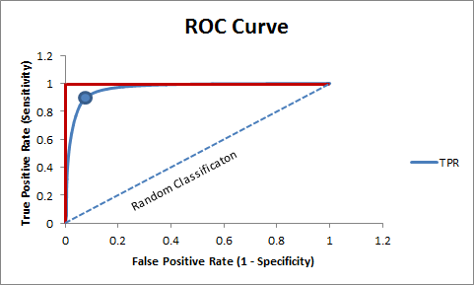

Figure 2.7: ROC Curve and AUC

#### Area Under the Curve (AUC)

AUC is another measure of classification accuracy. AUC is the area under the ROC curve (see Figure2.7), meaning the percentage of the area that is located under the ROC curve. The closer the AUC to 1 the more accurate the classification is. AUC is a useful evaluation metric because it serves as a single number summary of classifier performance. If we randomly choose

one positive and one negative observation, AUC represents the likelihood that our classifier will assign a higher predicted probability to the positive observation. AUC is useful even when there is a high class imbalance (unlike classification accuracy) [26].

## Semantic and Distance Matrices

There are many methods to calculate the similarity between two entities such as strings, numbers, rows of data, images and others [27]. Similarity is the measure of how much alike two data objects are [28]. Similarity measure in data mining context is a distance with dimensions representing features of the object [20]. High degree of similarity measure means small distance, while large distance will represent low degree of similarity. The degree of similarity is measured in the range of 0 to 1, Equation2.16explains the two main consideration measures.

*Similarity* = 1*, if X* = *Y*

.

0*, if X ƒ*= *Y*

(2.16)

Where *X* and *Y* are two objects.

Huynh,et al. [29] affirmed that popular string matching measures present the similarity of meta-data strings (author name, coauthors, affiliation, keywords) taking into account the author names based on family name and given name. These measures are: Edit Distance which is the distance between strings *X* and *Y* is the cost of the best sequence of edit operations that converts *X* to *Y* . Token-Based Measures convert the strings *X* and *Y* to token multi-sets and considers similarity metrics on these multi-sets. Hybrid Measures compare two long strings *X* and *Y* .

Naumann [28] summarized various similarity measures as illustrated in Figure2.8. In the next subsections, we will introduce the characteristics of some popular similarity measures.

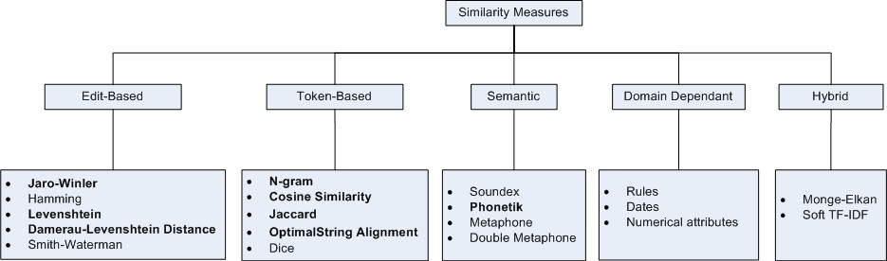

Figure 2.8: Similarity Measures, bold are the ones that we used

### Semantics

Semantics is the discipline of deriving meaning from a collection of words or symbols [30]. In computing, it also has something to do with finding meaning in data and refers to a flexible way of modeling it. Computing sentence similarity is not a trivial task, due to the variability

of natural language expressions [31]. The method for finding the similarity between long text (documents) is counting the shared words between the text pair, but for the short text we should find the co-occurrence if founded. This is why finding the text similarity using the known algorithms is unfair such as, Jaccard, JaroWinkler, Levenshtein and others, especially with long text documents.

Before computing the semantic similarity, there are some basic preprocessing techniques including the following [31]:

* + - 1. Document preprocessing phase: It is important to normalize the documents and adjust them for our needs. We must obtain tokens from the text, especially if it was written by different authors from different backgrounds. This phase will transform the documents into a common form through the following steps:
         1. Tokenization: Is the task of eliminating punctuation and other unwanted characters [32].
         2. Stop words: Words that have a small impact in the matching process such as, (a, and, but, how, etc).
         3. Stemming and lemmatization: Is the grammar and structure that documents use differently such as, *organize, organizes and organized*. Stemming is used to reduce all words to a common form such as three letters length, whereas, lemmatization removes the ending of the words and return the dictionary form, which helps to distinguish whether the word is used as a verb or as a noun. Both of them play an important roles in finding the semantic meaning behind the words which positively influence the semantic matching [33].
      2. Dictionary-based measures: In order to capture the semantic similarity between two sentences, we need a dictionary-based measures such as:
         1. WordNet: Is a large lexical database of English words, where nouns, verbs, adverbs and adjectives are organized by semantic relation to represent one concept [34].
         2. DISCO: Is a java application with a multi languages database of distributional similar words called **word space**. It also gives us the ability to create our own database of similar words [35]. The word space of DISCO consists of two types:

Col word space, which contains the word vector that represent the semantic meaning only (exclude the most similar words).

e.g Col(house, home)=0.652

Sim word space, which represents the word vector and the most similar words for each

e.g Sim(house,home)=0.7

but Sim(gasoline, lemonada)=0.159

* + - * 1. Europarl Corpus: Is a collection of about thirty million words for eleven languages of European Union [36].
      1. Transform Text to Vector: Transforming raw text into vector is a mandatory step for semantic algorithms [37]. Each vector has a length of vocabulary and each value in the vector is the number of co-occurrences of word to its index.
      2. Once we formed the semantic vectors for the work titles pair, we computed the similarity between them using a mathematical model such as cosine similarity.

### Levenshtein Distance

The notation of string changing operations is the fundamental of the Levenshtein distance idea in order to determine the degree in which two strings differ from each other. To transform string s1 into string s2 we need a minimum number of character insertions, deletions, and replacements [38]. For example Figure2.9describes the steps for finding the minimum edit distance between two strings (man and moon) which is *lev*(*man, moon*) = 2.

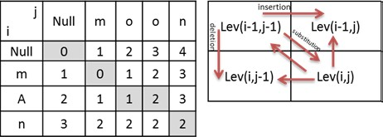

Figure 2.9: Levenshtein distance

Assume there are two strings, *S*1 and *S*2, the logic to calculate the Levenshtein distance

*LS*1*,S*2 (*i, j*) is shown in Equation2.17and2.18[](#_bookmark62)39[]. If *min*(*i, j*) = 0

*LS*1*,S*2(*i, j*) = *max*(*i, j*) (2.17)

Otherwise,

*min*

*LevS*1*,S*2 (*i −* 1*, j*) + 1

*LevS*1*,S*2 (*i, j −* 1) + 1



*LevS*1*,S*2 (*i −* 1*, j −* 1) + 1(*S*1*i ƒ*= *S*2*j*)

(2.18)

Where, *LS*1*,S*2 (*i, j*) is the distance between the first *i* characters of *S*1 and the first *j* characters of

*S*2.

### Damerau Levenshtein Distance

Damerau Levenshtein distance is calculated in the same way as the Levenshtein distance is, except that transposition of two adjacent characters is also allowed as an edit operation [40]. For example, the Levenshtein distance between the words *ppu* and *pup* would be 2, but the Damerau Levenshtein distance would only be 1 since the transposition of *p* and *u* is considered a single operation. Damerau Levenshtein distance was mostly used for spelling checks as the four edit operations covers over 80% of human misspellings [41]. Damerau Levenshtein equation is similar to Levenshtein distance with one addition recursion for the transposition operations as illustrated in Equation2.19

*LevS*1*,S*2 (*i −* 1*, j*) + 1





*min LevS*1*,S*2 (*i, j −* 1) + 1 if *i, j >* 1 *and ai* = *bj−*1 *and ai−*1 = *bj LevS*1*,S*2 (*i −* 1*, j −* 1) + 1(*S*1*i ƒ*= *S*2*j*)



*LevS*1*,S*2 (*i −* 2*, j −* 2) + 1

(2.19)

### Jaro Similarity

"Jaro is based on the number and order of the common characters between two strings; it takes into account typical spelling deviations and mainly used in the area of record linkage" [28,42]. Jaro Winkler is an extension of Jaro distance which gives the first few letters more favorable rating and is used with longer string records [42]. If *m* is the number of matching characters and *t* is the number of transpositions then Equation2.20will determine the search range for matching characters and Equation2.21will calculate Jaro similarity between two strings *x* and *y* of length *|x|* and *|y|* respectively.

*m* = *max*(*|x| , |y|*) 1 (2.20)

*−*

2

*sim*

= 1 . *m*

+ *m* + *m − t*Σ (2.21)

*jaro*

3 *|x|*

*|y| |m|*

### Jaccard Similarity

Jaccard similarity (*j*) is computed as the number of shared terms over the number of all unique terms in both strings [42]. It can be used to represent the similarity between two documents where value is between 0 and 1. The value 0 means the documents are completely dissimilar while value 1 means the documents are full matched.

The Equation2.22is used to calculate the Jaccard Index in steps: First, it counts the number of unique words(union) in both sets. Second, it counts the total number of shared words(intersection)

in both sets. Finally, it divides the intersection number over the union number.

*j*(*A, B*) = *|A ∩ B|* = *|A ∩ B|*

0 ™ *j*(*A, B*) ™ 1 (2.22)

*|A ∪ B| |A|* + *|B| − |A ∩ B|*

Where, *A* and *B* are two sample sets of length *|A|* and *|B|* respectively.

### Cosine Similarity

Cosine similarity is a measure of similarity between two vectors of an inner product space that measures the cosine of the angle between them [42]. This technique makes sense in space that has multi dimensions with points represented as vectors with integers or boolean. The cosine distance between two points is the angle that the vectors to those points make. This distance is based on the relative frequency of words in a document.

The range of the angle is between 0 and 2*π*. 0*◦* represents full similarity documents and

above 90*◦* represents dissimilar documents. Two vectors with the same orientation have a cosine similarity of 1, two vectors at 90*◦* have a similarity of 0, and two vectors diametrically opposed have a similarity of -1 independent of their magnitude [43,44].

Figure2.10shows how to calculate cosine similarity between the words *man* and *moon* in the documents *Doc*1 and *Doc*2. For each document in the Cartesian coordinate system, there is a point that represents the count number of each of the words *man* and *moon* in each of the two documents. *Doc*1, has 12 *man* words, and 14 *moon* words , a point at (12*,* 14). With regards to *Doc*1, the two words in *Doc*2 are represented with point (5*,* 11). *Doc*1 document would be an arrow going from the origin to point (12*,* 14) and *Doc*2 document would be an arrow from the origin to the point (5*,* 11) and *θ* is the angle between the two vectors. Equation2.23is used to calculate the cosine similarity.

*Similarity* = *cos*(*θ*) =

*A.B*

*ǁAǁ ǁBǁ*

(2.23)

Where A and B are two vectors with length *ǁAǁ*, *ǁBǁ* respectively.

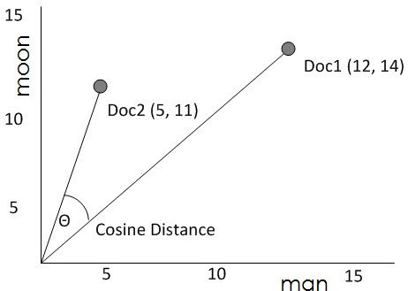

Figure 2.10: Cosine distance

### N-Grams Similarity

N-grams are simply all combinations of contiguous words or letters of length *n* that can be find in the source text. Unigram refers to n-gram of size 1, Bigram refers to n-gram of size 2, Trigram refers to n-gram of size 3. Higher n-gram refers to four-gram, five-gram, and so on [45].

Figure2.11illustrates a typical example of a sentence may be considered as "This computer is a good one". Its unigram is considered a single word where its bigram considered as a pair of words and its trigram consists of three words.

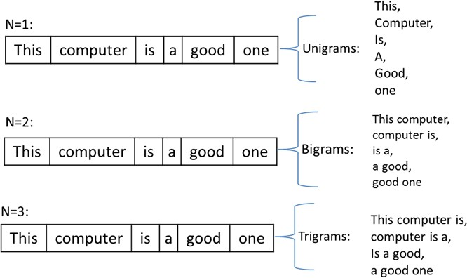

Figure 2.11: N-Grams overlapping

Equation2.24is used to calculate the distance between two strings a cording to the N-grams technique for each string.

*|G*(*s*1)*|* + *|G*(*s*2)*| −* 2 *|G*(*s*1) *∩ G*(*s*2)*|* (2.24)

Where, *|G*(*s*1)*|* and *|G*(*s*2)*|* are the combinations *G* of contiguous letters of length *n* for strings *s*1 and *s*2 respectively. The following steps are used to find the similarity based N-grams of size 3 between the two words *honorable* and *honest*:

* + - 1. *G*(*honorable*)=*{hon, ono, nor, ora, rab, abl, ble}*=7
      2. *G*(*honest*)=*{hon, one, nes, est}*=4
      3. *G*(*honorable*) *∩ G*(*honest*)=*{hon}*=1 4.distance( *honorable*, *honest*)=7+4-2*1=9

### Optimal String Alignment

Optimal String Alignment Distance algorithm (OSA) edits the distance by changing charac- ters if there are sentences that look like the other text. Then, according to OSA the "similarity" is

found and added to its total [46]. OSA is useful to fix spelling mistakes, editing mistakes and regular and irregular verbs. OSA works basically like Damerau Levenshtein algorithm (DL), the only difference is in how they transpose characters. DL algorithm can handle edits where the word has been misspelled twice while the OSA algorithm accepts one transposition and then moves on to the next substring.

For example, if we have two string: *ot* and *two*, then

*DL*(*ot, two*) = *ot → to → two* = 2

*OSA*(*ot, two*) = *ot → t → tw → two* = 3

# Chapter 3 Literature Review

Digital libraries and various meta-data schemes have rapidly grown. The internet and meta- data encoding in general move towards exchanges between a range of researchers, or similar research areas from several different authors, or even between different versions of the same scientific field [47]. This sheds light on the problem of name disambiguation. Databases and search options must be able to answer whether two articles were written by the same author or not. On the other hand, a researcher needs to know who exactly wrote this article for a purpose of future research collaboration or asking some questions about the data.

Many researchers have presented several definitions to illustrate the concept of AD. The author’s name ambiguity decreases the performance, quality and reliability of information from digital libraries [9,10,48]. While 3[,](#_bookmark174)49[] defines AD as an author information that negatively influence the retrieval of bibliographic query results. In [29,50] AD integrates the bibliographical data of publications from heterogeneous sources into unified database.

During our review we will explain many procedures that have been used to introduce a solution for the problem ofAD. Next sections will explain the most representative automaticAD methods found in the literature.

## Type of Approach

The way to organize the author’s names disambiguation methods is according to the type of approach they trade on. We will explain this in the following discussion [51]

### Author Grouping Methods

This method uses clustering technique to find the similarity between the attributes from a group or references, or extracts the relationships among authors and coauthors from citations [10]. Different similarity functions such as, Edit Distance, Token-Based Measures and Hybrid Measures achieve the goal of finding the similarities between references for the same authors [29]. Also, there are many different ways to measure the similarity between all attributes of two

publications such as, Jaccard, Levenshtein, Jaro, etc [48]. Graph-based similarity method can create a co-authorship graph for ambiguous groups [51]. Each element of author’s name and coauthor’s name attribute is represented by a vector [10,49,50].

### Unsupervised Techniques

Unsupervised learning clustering is the process of grouping a set of objects into classes of similar objects. In these approaches, ambiguous citations are clustered into groups of distinct authors by measuring the similarities between the attributes in the citations [3]. In this research, the most used techniques are [51]:

First, spectral clustering, clusters data that are connected but not necessarily clustered. It is mainly computed through eigenvalues and eigenvectors. The name disambiguation problem for author’s citations is represented as a partition of the graph. This means that similar citations are tied to the same cluster.

Second, partitioning clustering, which constructs a partition of *N* documents into a set of *K* clusters. The final technique is the hierarchical clustering which groups the references of authors by building a tree-based Hierarchical taxonomy [3,10].

### Supervised Techniques

These approaches try to model all authors’ patterns from a set of training data. In general, data provide insights in how to capture the implicit knowledge of a domain, and this method can be accurate and reliable when the data are represented well. Table3.1illustrates this.

Examples of supervised approaches are: Naive Bayes model [9], Support Vector Machine (SVM) [9,29], Grouping algorithm [3], Deep Neural Network (DNN) [48,](#_bookmark219)[52] and other approaches such as Random Forest, K-Nearest Neighbors (kNN) and Decision Tree (C4.5) [29].

## Database

Various types of data with different format have been used in literature such as publication lists collected from the trusted and official web-sites e.g Microsoft Academic Search, ACM Digital Library, IEEE Digital Library, DBLP, PubMed, etc. Preparing and understanding the data is the first step to disambiguate the authors’ names problem. Most of the proposed algorithms use the last-name and first-initial to refer to the same author [3](#_bookmark174),[9,](#_bookmark180)[29,](#_bookmark200)48[,](#_bookmark219)52[] .

## Features Information

Choosing the right features set is the most and the highest important step in the prepossessing phase inAD. Good features are those that can improve the accuracy and have the capability

to work with any new database. Here are some descriptions of some terms that are linked to features in this literature.

To disambiguate author’s names, different features and methods have been used. Table3.1 shows the information of the feature attributes in the literature. These kinds of evidences fall into three categories [51]:

The first category is Citation Information. It refers to the attributes that have been extracted from the citations such as coauthors’ names, work title, journal title, year of publishing, etc. This citation information is commonly founded in all citations [3,9,10,29,47 –50,52,53]. The category contains also some additional features such as emails, addresses, paper headers which are not always available. They usually help us to disambiguate names.

The second category is Web Information: It represents data from web used as additional information to improve the disambiguation task [50,53]. On the other hand, there is one problem which is the additional cost of extracting all the needed information from the Web documents [51]. Web Information involves some steps for obtaining information [54]. It extracts a citation attributes, then it submits the attributes as a query to a search engine to find pages containing publications of the authors e.g. Query: "author’s names" + "publications" + work title "Author’s Names Disambiguation" and finally it collects the answer of each query.

The third category is Implicit Evidence which is divided into: First, author-related features such as email and author’s name. Second, article-related features such as, article title, publication title, keywords, abstract , etc. which help a lot to estimate and calculate the similarities among references of authors.

Table 3.1: Outline of Disambiguation Procedures

|  |  |  |  |  |  |
| --- | --- | --- | --- | --- | --- |
| **Ref.** | **Type of**  **Approach** | **Used**  **approaches** | **Used**  **database** | **Evaluation**  **The experiment** | **Used**  **Features** |
| [9] | Supervised | Naive Bayes probability model Support Vector Machines | Publication from homepages DBLP citation databases. | Accuracy. | Co-author names The title of the paper  The title of the journal |
| [3] | Supervised | Grouping Algorithm  C-SVC binary classifier Cluster Filter | DBLP citation databases | Precision rate  Recall rate Accuracy | Co-author  The attribute title Venue |
| [10] | Unsupervised | K-way spectral clustering | DBLP citation databases Publication lists | Pair-Wise Similarity Metrics( CSM  MSF)  Similarity Metrics for Topic Correlation( TSM)  Similarity Metrics for Web Correlation(  MNDF) | Co-author Paper title Venue title |
| [48] | Supervised | Deep neural network  string-matching measures( Jaccard Levenshtein, Jaro  Jaro-Winkler, Smith-Waterman and  Mogne-Elkan) | Vietnamese author dataset | k-fold cross-validation Accuracy | Author name Affliations Co-authors  Paper keyword |
| [52] | Supervised (pairwise classification) | Deep neural network(DNN) DNN symmetry | DBLP databases | Precision (P), Recall (R) AUC and  Accuracy | Co-authors names Paper title  Publication venues |
| [49] | Unsupervised (name string only) | Author Co-citation Analysis (ACA) | PubMed | Factor analysis  ACA mapping between lastname first initial and SPSS Oblimin | Chinese and Korean authors Last name, first initial |
| [29] | Supervised | Random Forest  Support Vector Machine (SVM) Nearest Neighbors (kNN)  C4.5 (Decision Tree) and Bayes | Microsoft Academic Search ACM Digital Library  IEEE Digital Library | String Matching Measures(Edit Distance Token-Based Measures  Hybrid Measures)  Average accuracy | Author name Co-authors Affiliation  Keywords in publications |
| [53] | Supervised  (name string only) | Characteristic Scores and Scales (CSS) | Researcher-ID data of  4.271 registered researchers | A Spearman rank correlation Mean Normalized  citation Rate (NMCR)  Relative Citation rate (RCR) | Researcher ID  At least 20 registered publication Year  Chosen reference standard |
| [50] | Unsupervised | graph-based approach | Citeseer  Digital Libraries | By-hand checking accuracy | Self-citation  Co-authorship and Document source analysis |

## Experiments Evaluation

One of the most important point is to understand the evaluation of the experiments that have been used in the literature, to walk-through the various techniques used by the researchers to disambiguate authors’ names problem. We should pinpoint on the following points:

### The Mean and Standard Deviation

In [9,10], the Mean and Standard Deviation statistical analysis were used to examine the accuracy ("according to ISO 5725-1 the general term accuracy is used to describe the closeness of a measurement to the true value") of experiments that have been used by some machine learning approaches to disambiguate authors’ names in the paper title, journal title and the probability in which two citations belong to the same author. Therefore, using these statistical measurements show that changing the training data size will change the performance of the name disambiguation algorithm.

### Experiments Design and Evaluation

Experiment design is a careful balancing of several features including, author name pattern, dataset, samples size, attributes and citations records. Every aspect in the designing phase plays an important role to construct a reliable model that can be obtained and correctly interpreted. Evaluating the experiment methods after they have been carried out is one of the core stages in the data process. Table3.2illustrates the setup and the evaluations techniques that have been used by different studies.

## Related works

Unlike supervised machine learning approaches, Ibrahim M.Qdemat [55] proposed a heuris- tic based system in which all publications of a given author can be aggregated in the same profile.Qdemat also designed an algorithm that uses the publication meta-data and mainly he used email, name string similarity, affiliation and co-authors features.We will proposed a super- vised machine learning approach that uses the features of ORCID citation attributes, to train the system to disambiguate author names.Particularly, to built classifier based on those attributes is a significant challenge.

In Shahd’s Zeiad Ewawi [56] thesis, a comparison between different types of clustering algorithms was held to solve the ambiguity of author’s names. Various features are involved in the clustering process: last name, author’s other names, affiliation, title, abstract, keywords and co-authors. The aim of Shahd’s study is controlling the behavior of the clustering algorithm in order to reduce the effect of the data uncertainty by applying a set of rules. Term Frequency

Inverse Document Frequency (TF-IDF) algorithm was used for extracting distinctive terms from features values.

*Chapter 3. Literature Review*

30

Table 3.2: Outline of Disambiguation Performance

|  |  |  |  |  |  |  |  |  |  |
| --- | --- | --- | --- | --- | --- | --- | --- | --- | --- |
| Ref. | Author name  pattern | Data set | Data set  size | Citation  size | Citation  based | Attributes | Experiment  evaluation | Accuracy | Most useful  Information |
| [3] | First name initial and Last name | DBLP website | 476 individual authors | 8,441 | Yes | Coauthors  Title Venue | Precision rate Recall rate | 75% | Coauthors the most useful Title better than venue |
| [10] | First name initial and Last name | DBLP website | 14 DBLP name data sets | 400,000 | Yes | Coauthors  Title Venue | Standard Deviation | 61.5% to 64.7%  average accuracy | Coauthors the most useful Title better than venue |
| [53] | Author profile | Researcher-ID  data from 8 selected countries | 20 different authors | 4,271 | No | Publication year  Researcher ID Field of study | Relative Citation Rate (RCR)  Mean Normalized Citation Rate (NMCR) | 69.80% | Field of study Publication year |
| [9] | First name initial and Last name | DBLP website | 9 individual authors | 300,000 | Yes | Author names  Paper title Journal title | The mean and  The standard deviation (StdDev) | Two data sets achieved 90% by SVM  Average=73.3% by Naive Bayes approach Average=65.4%,by SVM | Journal title |
| [48] | Author instance names | Online digital libraries:  IEEE Xplore ACM  MAS | 10 data sets | 30,537 | No | Author name  Co-author Affiliation keyword | Prediction error rate F-measure | 91.31% | Features not ranked |
| [29] | Family name and given name | Online digital Libraries:  Microsoft Academic Search ACM Digital Library  IEEE Digital Library | 10 data sets | 4,350 | No | Coauthor names  Paper title keywords  Journal title keywords | Non | 98.33% | Features not ranked |
| [50] | Family name | Citeseer | 8 data sets | 4,799 | Yes | Co-authorship and Source URL meta-data | Precision  Recall  F-measure | Achieving precision of 0.997 Recall of 0.818 | Features not ranked |
| [5] | Author instance names | Scopus and WoS | Undefined | 1,518 | Yes | Coauthors  Paper title  URLs of the papers  The name of the scholar | Precision Recall  F-measure | Precision=95.38% Recall=96.24%  F-measure=94.54% | Features not ranked |

# Chapter 4

**Methodology and Data Analyses**

In this chapter we provide the comprehensive and detailed analysis of data sets forAD. The main result of existing data sets is created, represented, and used. In order to present a solution forAD, we must use a representative database that covers various names from different nationalities. In this section we will describe the technique and the process to build the data for validation stage.

## ORCID Database

Once per year, ORCID releases a downloadable data file that contains a copy of all public data in its registry. This file contains the public information associated with each ORCID user in both JOSN and XML format. In this thesis, we used Orcid Public-Data-File-2015 which contains over 1.6 million records.

### Datasets Selection

Selecting the datasets from ORCID database is the most important phase. Our criterion is to have variety samples that would represent as much cases as possible in the entire database. The selection methods are based on the following steps:

* + - 1. We determined the first name and last name from ORCID profile files for each author.
      2. LNFI is used as a primary key to filter the authorship records of ORCID datasets. We retrieved from ORCID database all author strings of the selected LNFI . Then, all citations which consist of coauthors name strings, journal title, work title and the year of publishing that contains one of these author names are retrieved from ORCID database.
      3. We calculate the frequency of the distinct LNFI then we retrieve all documents based on these names from ORCID database. Calculating the frequency for each LNFI helps us in choosing different sizes of representative authors’ clusters. This is a good indication for evaluating the disambiguation of names.
      4. We select different LNFI from various backgrounds to have better representations of all authors.

### Database and Labeling

This section describes the data sets that we use for the experimental and evaluation phases. Table4.1lists a sample data sets that we choose randomly in our experiments. These data sets are labeled from ORCID engine through the registration process.

Table 4.1: Orcid Datasets Samples

|  |  |  |  |  |
| --- | --- | --- | --- | --- |
| **#** | **Dataset** | **Criteria (LNFI)** | **Size of documents** | **ACC Records** |
| 1 | Wang | Wang,Y | 916 | 86,462 |
| 2 | Zhang | Zhang,Y | 829 | 293,472 |
| 3 | Lee | Lee,J | 717 | 176,820 |
| 4 | Li | Li,J | 563 | 46,010 |
| 5 | Kim | Kim,J | 678 | 332,070 |
| 6 | Ahmad | Ahmad,K | 16 | 9,702 |
| 7 | Liu | Liu,Y | 672 | 78,462 |
| 8 | Chen | Chen,Y | 545 | 9,120 |
| 9 | Park | Park,J | 350 | 52,670 |
| 10 | Kumar | Kumar,A | 297 | 118,680 |
| 11 | Wu | Wu,J | 252 | 141,000 |
| 12 | Silva | Silva,A | 160 | 266,772 |
| 13 | Brown | Brown,D | 41 | 177,662 |
| 14 | Islam | Islam,M | 127 | 12,240 |
| 15 | Sun | Sun,X | 121 | 2,450 |
| 16 | Ali | Ali,M | 106 | 756 |
| 17 | Carvalho | Carvlho,A | 71 | 16,256 |
| 18 | Fernandes | Fernandes,A | 48 | 54,522 |
| 19 | Nguyen | Nguyen,T | 169 | 96,087 |
| 20 | Santos | Santos,R | 72 | 3,306 |
| 21 | Smith | Smith,J | 122 | 1,640 |
| 22 | Wang | Wang,X | 637 | 77,588 |
| 23 | Zhang | Zhang,X | 566 | 2,250 |
| 24 | Baker | Baker,M | 16 | 56 |
| 25 | George | George,J | 18 | 1,560 |
| 26 | Liu | Liu,C | 303 | 237,656 |
| 27 | Oliveira | Oliveira,A | 87 | 10,2080 |
| 28 | Sharma | Sharma,S | 167 | 2,162 |

We will use cross validation technique to assess the performance of machine learning model which enables us to know how the machine learning model would be generalized to an independent data set and to estimate how accurate the predictions will be in practice. Table4.2 represents the total number of citation records that were chosen randomly to represent all data sets in Table4.1.

We split these citation records into two types of data sets, the known data (Cross validation set) and the unknown data (Final test set). By using cross validation, we would be "testing" our machine learning model in the "training" phase to check for overfitting and to generalize the model we will use for an independent data, which is the testing data. For cross validation rounds,

we divided our original training data set into two parts, cross validation training set and cross validation testing set or validation set.

Table 4.2: Training and Testing samples

|  |  |  |  |
| --- | --- | --- | --- |
| **#** | **Test Purpose** | **Quantity** | **Total number of**  **citations pairs** |
| 1 | Cross validation set | 1606214 | 803107 |
| 2 | Final test set | 401552 | 200776 |

## Methodology

### Design Rules

Our aim is to provide a sequence of different cases to guide us during the design process strategy in order to reach the goal of solving the names ambiguity depending on ORCID citations. ORCID represents authors from various backgrounds and cultures; this variety leads to different labels which are reported to be ambiguous in author’s names. Towards the end of the following subsections, we explain the main keys of our design principles.

#### Notes on ORCID Profile

The following are some points that we should be aware of through the design phase process 1.ORCID-profile: Each author has one profile with only one ORCID-ID.

2.There are some blank elements in author’s profiles in ORCID database. 3.Some elements have all the fields while others do not.

1. The main source of author’s details is ORCID-activities which consist of affiliations and ORCID-work.
2. Affiliations include the department’s name and the organization’s name. However, affilia- tions are not included in some parts of ORCID profiles. At least one of them is listed for the author who has creative works.
3. ORCID-activities do not exist for an author who asks for an ORCID-ID also, ORCID-work does not exist for someone who is involved in a scholarly work.
4. Keywords are not always available.

In the next subsections we propose a method using ORCID open database to solve theAD problem based on citations records.

#### Citation Representation

In ORCID database, each profile that belongs to an active author has at least one citation record which consists of various information such as, co-authors, journal title, work title, publishing year,..etc. As shown in Figure4.1, citations records have two different types, Bibtex formatting style and None-formatted style.

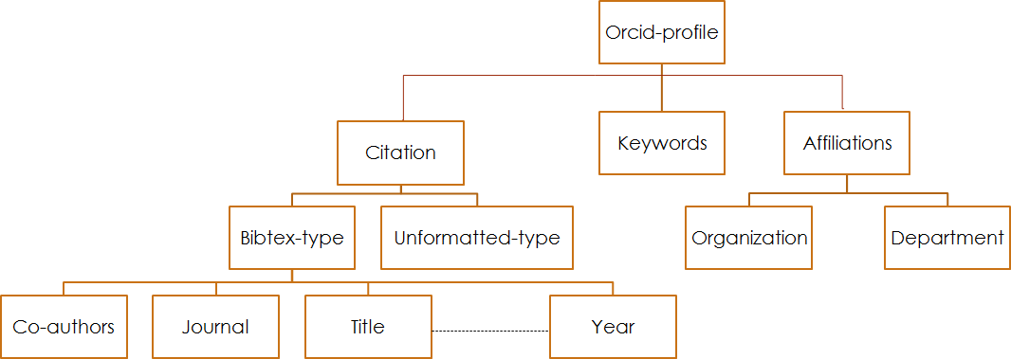

Figure 4.1: Citation Architecture

Our citation criteria will be based on the following points:

* + - * 1. In the query result we will exclude the none-formatted citation type from the data sets. 2.The citation features based on co-authors, journal title, work title and publishing year. 3.Random number of citation records was represented in each data set sample.

1. In order to establish positive and negative pairs, number of citations in any profile must be more than 2.
2. Positive pair *Ppair* is the representation of any two different citations from the same author’s profile, e.g

0000-0002-3562-2323;**16051195**;Zhang,Y

0000-0002-3562-2323;**14022797**;Zhang,Y

The bold number in the ORCID ID is a primary key for citation records. To collect these pairs we used two methods:

**First**, compiling pairs of citations from the same profile, so that these pairs are separated and not repeated in any record of the other pairs. Figure4.2illustrates this criteria. The number of positive pairs *n* from each dataset could be calculated according to Equation 4.1.

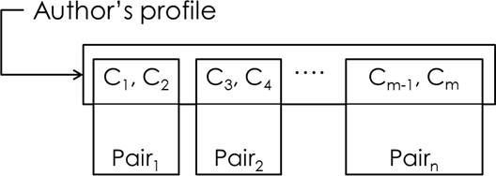

Figure 4.2: Positive pairs for separated citations from an author’s profile

*Lastp m*

Σ , ,

*n* =

2

(4.1)

*Firstp*

Where, *Firstp, Lastp* are the authors’ profiles range in each dataset, and *m* is number of citations in author’s profile. We use this method to generate more positive pairs. Algorithm

* 1. used to collect a random number of positive citation pairs from separated citations belongs to the same author’s profile.

**Algorithm 1** Positive Citation Pairs Algorithm from separated citations

1: *Function Ppair*(*Profile p*)

2: for p in Dataset LNFI

3:

*{*

4: let i=1

5: let j=2

6: for citation m in p (1 to random)

7:

*{*

8: pair=(m[i],m[j]);

9: *return pair*

10: i=j+1

11: j=i+1

12:

*}*

13:

*}*

14: Endfunction

**Second**, compiling chain of positive pairs of citations from the same profile. The first pair consists of the first two citations then the second citation is linked to the third one to construct the second pair and so on. Figure4.3illustrates this criteria. The number of pairs *n* from each dataset can be calculated according to Equation4.2.

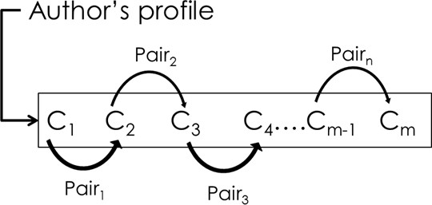

Figure 4.3: Positive pairs for one author profile (Chain of citations)

*Lastp*

Σ

*n* =

*Firstp*

*m −* 1 (4.2)

Algorithm (2) is used to collect a random number of positive pairs from chain of citations that belong to the same author’s profile.

**Algorithm 2** Positive Citation Pairs Algorithm

1: *Function Ppair*(*Profile p*)

2: for p in Dataset LNFI

3:

*{*

4: let i=1

5: let j=2

6: for citation m in p (1 to random)

7:

*{*

8: pair=(m[i],m[j]);

9: *return pair*

10: i++

11: j++

12:

*}*

13:

*}*

14: Endfunction

1. Negative pairs are the representation of any two citations from different authors’ profiles, e.g.

0000-0001-7636-7368;**14180633**;Zhang,Y

0000-0001-8286-300X;**15159439**;Zhang,Y

To collect these pairs we used two methods:

**First**, compiling pairs of data from different profiles so that each record from author’s profile *P* 1 is linked to one record from a different author’s profile *P* 2 without duplication. Figure4.4illustrates this criteria.

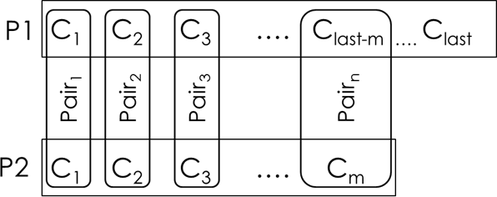

Figure 4.4: Negative pairs (First Method)

The number of pairs *n* from each dataset could be calculated according to Equation4.3.

# *profiles*

Σ

*n* =

*i*=1

*min*(#*citationpi,* #*citationpi*+1 ) (4.3)

Where, #*citationpi* and #*citationpi*+1 are the minimum number of citations in both profiles. Algorithm (3) is used to collect a random number of negative pairs form two different authors’ profiles taking into account the one-to-one relationship between the citations in each profile.

**Algorithm 3** Negative Citation Pairs Algorithm(one-to-one relationship)

1: //P1,P2 are two different profiles

2: let x=count(citation in P1) 3: let y=count(citation in P2) 4: let z=min(x,y)

5: *Function GetCitation*(*Profile p, int i*)

6:

*{*

7: for citation c in p

8: if c[i]==True //is found

9: *return c*

10: else()

11: endif

12:

*}*

13: Endfunction 14: for i=1 to z 15: *{*

|  |  |  |
| --- | --- | --- |
| 16:  17: |  | First=GetCitation(P1,i) Second=GetCitation(P2,i) |
| 18: |  | *return pair*(*First, Second*) |
| 19: | *}* |  |

**Second**, compiling pairs of data from different profiles so that each record from profile *P* 1

is linked to all records in profile *P* 2 without duplication. Figure4.5illustrates this criteria.

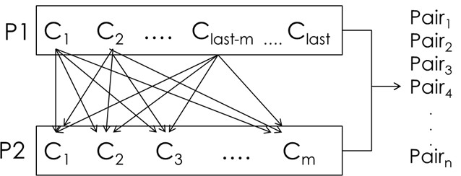

Figure 4.5: Negative pairs (Second Method)

The number of pairs *n* from each dataset could be calculated according to Equation4.4

# *profiles*

Σ

*n* =

*i*=1

#*citationpi ×* (#*citationpi*+1 *−* 1) 2

(4.4)

Algorithm (4) is used to collect a random number of negative pairs from two different authors’ profiles taking into account the one-to-many relationship between the citations in each profile.

**Algorithm 4** Negative Citation Pairs Algorithm(one-to-many relationship)

1: //P1,P2 are two different profiles

2: let x=count(citation in P1)

3: let y=count(citation in P2)

4: *Function GetCitation*(*Profile p, int i*)

5:

*{*

6: for citation c in p

7: if c[i]==true //is found

8: *return c*

9: else()

10: endif

11:

*}*

12: Endfunction 13: for i=1 to x 14:

*{*

15: First=GetCitation(P1,i)

16: for j=1 to y

17:

*{*

18: Second=GetCitation(P2,j) 19: *return pair*(*First, Second*) 20: *}*

21: *}*

The next subsection describes the citation methodology based on Co-authors, Journal title, Work title and Publishing year features.

### Coauthor Methodology

Since ORCID contains records from different backgrounds, we found various format of the author’s names inside each citation block. We summarized them as follows:

* + - 1. One part string name. The family name or the first name. e.g

*kumar,*

* + - 1. Two parts string name. The full first name followed by the full family name or the full family name followed by the full first name. The same for names with abbreviations.

e.g

*kumar, akhilesh kumar, A.*

1. Three parts string name which represents the first name, middle name and the family name.

In some cases one or two of the names parts with their first initials e.g

*Alexander, Swathy A*

*Alexander Swathy Ann Alexander, S. A.*

1. Four parts string name which represents the first name, two middle names and the family name. In some cases from one to three names written with their first initials

e.g

*Permana A D C*

*Permana, Antonius Dimas Chandra*

ORCID File Structure subsection clarifies the personal information for each author. The arrange- ments of the main authors’ names are a sequence of the given-name (first name) then the family name. Figure4.6describes the representation of the coauthors in the bibtex citations format which comes in two types, last name then first name (or the abbreviation LNFI) or first name then family name (or the abbreviation FNLI).

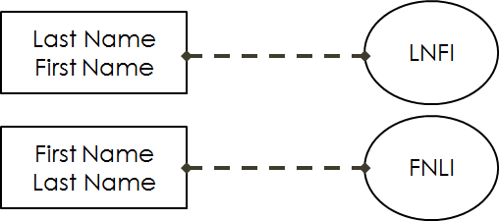

Figure 4.6: Coauthor’s Names Structure

We implemented Jaccard, JaroWinkler, Cosine, Levenshtein and NGram string similarity technique to represent the similarity between two pairs of coauthors lists. In order to be more accurate, we believed that we had to take into account the ambiguity of coauthor’s names, so we calculated the similarities in two ways:

Firstly, Full Matching(FM) names when the two coauthors are completely identical. For example, when the similarity score is 50% that means one coauthor’s name is shared in two citations records. When the similarity score is 75% that means two coauthor’s names are shared in two citations records. When the similarity score is 100% that means three or more coauthor’s names are shared in two citations records.

Secondly, When the number of shared coauthor’s names in two citation records is less than or equal to two. Then the algorithm will calculate the Partial Similarity(PS) match as the same technique of the full string match. The weight of the PS will be 25% and this will ensure that the partial match will not exceed 25% of the Total Similarity(TS) of any pair. Equation4.5is used to calculate the coauthor’s pairs score.

*TS* = *FM* + (*PS ∗* 0*.*25) (4.5)

Algorithm (5) introduces the way of calculating the TS between each positive or negative pair in coauthors’ list.

**Algorithm 5** Coauthors Score Algorithm

1: initialize i,j,Counter1,Counter2 to zero

2: *Function GetScore*(*Algorithm A, Coauthors c*1*, c*2)

3:

*{*

4: score=A(c1,c2)

5: *return score*

6: Endfunction

7:

*}*

8: *Function GetSimilarity*(*Counter C*)

9: *{*

10: *Match* =

0*.*5 if *C* = 1

0*.*75 if *C* = 2



1 if *C* “= 3

11: *return Match*

12:

*}*

13: Endfunction

14: for Coauthors c1 in citation1

15:

*{*

16: i++

17: For Coauthors c2 in citation2

18:

*{*

19: j++

20: *score* = *GetScore*(*Gname, c*1[*i*]*, c*2[*j*])



Jaccard

JaroWinkler

21: *where, Gname* =

22: If score==1 then

23: Counter1++

24: else

25: Counter2++

26:

*}*

27: if Counter1>=3

28:

*{*

29: FM=GetSimilarity(Counter1)

30: else

31: FM=GetSimilarity(Counter1)

32: PS=GetSimilarity(Counter2)

33:

*}*

34: TS=FM+(PS*.25)

35:

*}*

36: *return TS*

Cosine Levenshtein

NGram



This technique is designed to ensure that two similar items generate hashes that are themselves similar. In fact, the similarity of the hashes has a direct relationship to the similarity of the

citations they were generated from. The final step is to use a machine learning technique to choose the promising similarity method that helps us to predict whether each pair of coauthors belongs to the same author or not.

### Publishing Year Methodology

We believe that publishing year plays an important role as the other used features. It could give some indications about authors, especially when they submit everything new in their field of research. We found a lot of researchers publishing in the same year or within a period of two or three years. The criteria of calculating the score of publishing year based on the following: First, The publication year score (*Ys*) is equal to one if two publications were published in the same year. Second, If the publications were published in different years, then the *Ys* will calculated as shown in Equation4.6.

*Ys* =

1

*|y*2 *− y*1*|*

(4.6)

Where *|y*2 *− y*1*|* is the absolute value of the difference between the publication years from the citation pair.

Algorithm (6) describes the criteria of calculating the score of any publication years.

**Algorithm 6** Publishing year Score Algorithm

1: *Function year*(*pair y*2*, y*1)

2: *{*

3: *D* = *y*2 *y*1

*| − |*

4: if *D*==0 then

5: *Ys*=1

6: else

7: *Ys*=1/*D*

8: *return Ys*

9:

*}*

10: EndFunction

### Journal Title Methodology

Authors publishing their researches in the same journal or in different journals are highly concerned about the correct journal to submit their papers. The question regarding journal choice is : should they submit their work to the same journal or not? Technically, it is perfectly acceptable to submit two or more papers to the same journal. This way ensures that the author’s readers will get a clear idea about his work, making the formatting much easier and the author more familiar with the style of his work. Some authors believe that publishing in different journals shows that their work has been accepted by a wide range of academics and becomes

widely known [57]. Equation4.7calculates the similarity value between Journals.

*Js* =

0 if *ja ƒ*= *jb*

*>* 0 *and <* 1 if *PS*(*ja, jb*)

1 if *ja* = *jb*

(4.7)

Where *Ja, Jb* are the Journal titles that belongs to a pair of negative or positive citation and *Js* is the Journal similarity score. The technique we followed to compute the similarity between each pair of journals consists of the following steps:

**Step1**: Extract the Journal feature from the citations records for each LNFI data set in ORCID database. In this step, we removed the stop words and clean the journal names from unwanted symbols.

**Step2**: In order to find the score of the similarity between any pair of journals, we implemented seven string algorithms: Jaccard, Jaro, Cosine, Levenshtein, NGram, Soren distance and Damerau Levenshtein Distance.

**Step3**: The final step is to use a machine learning technique to choose the promising similarity method that helps us to predict whether each pair of Journals belongs to the same author or not. Figure4.7describes the process of calculating journal similarity using each string algorithm.

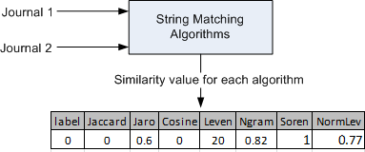

Figure 4.7: Journal Similarity

### Work Title Methodology

Computing string similarity is not a trivial task, because of the different of natural language expressions [31]. The technique of finding similarity between long texts focuses on the shared words in both, but in short text it focuses on word co-occurrence. Computing authors’ work titles using the traditional similarity measures is useless because these measures are based on the syntactic features and other based measures.

Figure4.8shows the functionality of finding the similarity between two work titles. In step 1 and 2, different techniques were used to find the semantic similarity between positive and negative work title pairs. We must obtain tokens from the work title and apply various normalization to adjust them for our needs. This will reduce the influence of grammatical reasons in addition to how words are formed, and their relationship to other words in the same language. We achieve that by: (1)Title tokenization; (2)Removing stop words; (3)Stemming and

lemmatization. Step 3 represents the total number of items in each title. Our methodology is able to find the semantic meaning of any title which consists of one word or more as clarified in step 4. Each title is treated as a bag of words or terms and is represented in a high dimensional space as a vector.

The dimension of the space depends on indexing terms which are chosen to be relevant for the collection dictionaries database. A collection of *n* documents can be represented in two vectors: Category vector represents the terms of the first sentence in the title pairs and the input vector represents the terms of the second sentence as shown in step 5. Each item in the vectors represents a dimension and all dimensions establish the space model. In step 6 we formed the semantic vector for each work title by processing each title sentence using a collection of dictionaries (En-Wikipedia, En-PubMedOA, En-BNC and WordNet) to help us extract the concepts related to the terms in each sentence. In step 7 the category vector consists of the terms and the occurrence of each term in the documents which has been retrieved from the dictionaries as illustrated in matrix *Category* in Equation4.8

*T erm Frequency* 

*Category* = 











*t*21 *f*22

*. .*

*. .*

*tm fmn*

(4.8)

Where, *m* is the number of unique terms in all documents, each row represents the term and the occurrence in all documents.

The input vector in Equation4.9is the same as the category vector but it ignores the terms that are not related to the synonyms in the category vector.

*T erm Frequency* 

*Input* = 











*t*21 *f*22

*. .*

*. .*

*tm fmn*

(4.9)

Once we formed the semantic vectors for the work titles pair in the space model, we computed the cosine similarity between them as shown is step 8 and finally step 9 represents the final result.

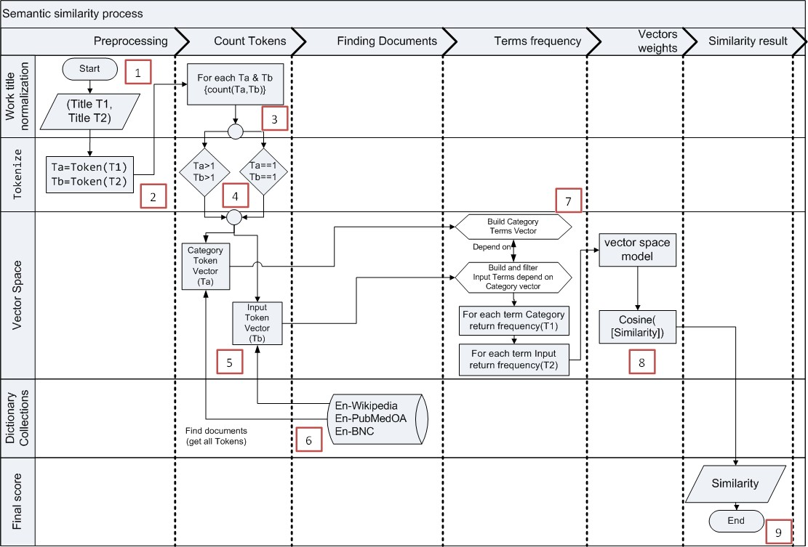

Figure 4.8: Sentence similarity computation diagram

### Machine Learning

In this section, we will use the dataset that we derived in Table4.2. The dataset is comprised of 1003,883 citation pairs. Our goal is to build a machine learning algorithm capable of detecting the correct citation (match or not match) in new unseen citation. In machine learning, this type of problems is called classification. Figure4.9illustrates the machine Learning phases. Training phase: In this phase, we train a machine learning algorithm using a dataset comprised of the citations and their corresponding labels. Prediction phase: In this phase, we utilized the trained model to predict labels of unseen citations.

The training phase forAuthor’s Names Disambiguation(AD) classification problem has two main steps: First, Feature Extraction: In this phase, we utilized domain knowledge to extract new features that will be used by the machine learning algorithm. Coauthors’ names, journal title, work title and publishing year are the features used inADclassification. Second, Model Training: In this phase, we utilized a clean dataset composed of the citations features and the corresponding labels to train the machine learning model. In the prediction phase, we applied the same feature extraction process to the new citation and we passed the features to the trained machine learning algorithm to predict the label.

In the ORCID dataset, we classify each record into one of two classes: First, class *Y es* means the citation pairs are matched and belongs to the same author. Second, class *No* means the citation pairs are mismatched and belongs to two different authors. Figure4.10illustrates the

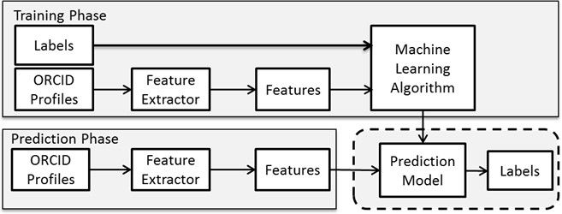

Figure 4.9: Machine Learning Phases

classification process which uses the training set to train the model to predict the unseen data (Testing set) using various models (Decision Tree (C4.5), Random Forest, Deep Learning and Naive Bayes).

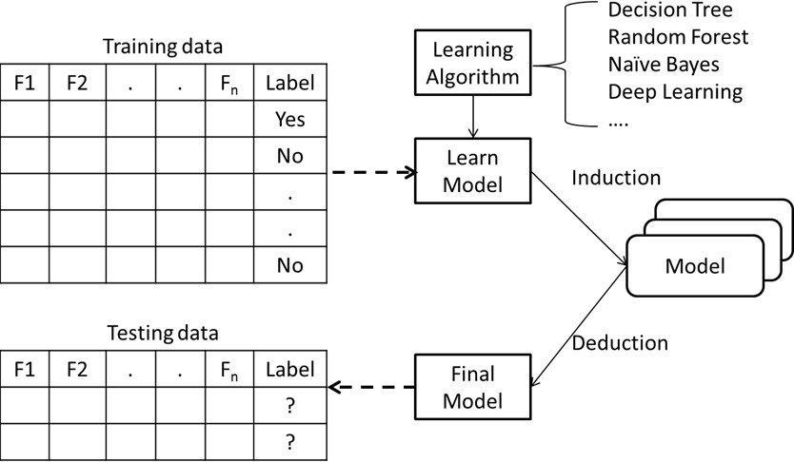

Figure 4.10: Weka Classification

In order to build a promising model that can achieve a high accuracy and a precise prediction on a set of unseen data we used various classifiers. Decision Tree, since the dataset contains continuous attributes, we utilized *C*4*.*5 as the primary algorithm which represented as J48 in Weka. In Random Forest there are only a few hyper-parameters we need to tune in Weka: The trees to build in Random Forest, the tree depth and the number of features which should be used for each tree. Using Naive Bayes, we assumed that the value of features are independent from others and that features have equal importance. Deep Learning which is represented as deeplearning4j in Weka. It is possible in Deep Learning to load predefined architectures as neural network and train it on a new dataset. In order to get additional performance we tweaked some parameters such as number of layers, learning rates, convolutional filters and processing parameters.

## 4.3 Chapter Summary

In this chapter as illustrated in Figure4.5, we presented the methods we used for extracting the features of the database, as well as the methodology that have been used to calculate the

similarity between the negative and positive citation pairs. A matrix of real numbers has been obtained from records scores that represent the similarity of each citation pairs in the data-sets consists of coauthors, journal title, work title and publishing year. Different machine learning classification approaches used to build a promising model that can achieve a high accuracy and a precise prediction for unseen citation records.

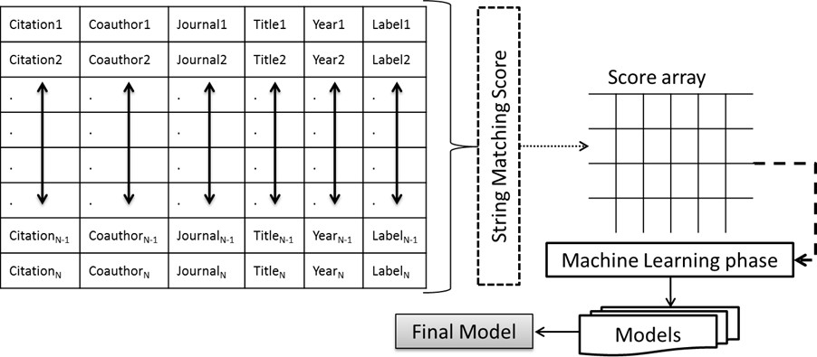

Figure 4.11: The Methodology Phases

# Chapter 5

**Experiments and Results**

In this chapter, different experiments are conducted in order to evaluate the improvement brought out by our methodology approach. The first section will describe the experiments setup. The evaluation approach of the classification result will be described in section 2. The comparison betweenRandom Forest(RF) versus Naive Bayes Classifier,Deep Neural Networks (DNN) andDecision Tree(J48) will be described in section 3. The last section will illustrate and analyze the experiment results, ranking the features, ranking the distance matrices and the execution time of predicting new instances.

## Experiments Setup

The classification methods were tested by using 10-fold cross validation technique to compare the performance of the machine learning approaches that we used. In each round of cross validation we partitioned the original data sets into training set and testing set. We trained our machine learning model using the cross validation training set and test it against the testing set. The training set contains 803,107 instances and the testing set contains 200,776 instances. We calculated theArea Under Curve(AUC) of the machine learning models by validating the predicted results against the test set. Averaging the accuracies derived in all the 10-folds cases of cross validation to estimate the accuracy of our model.

We implemented four machine learning approaches, namelyRF, Naive Bayes Classifier, DNNandJ48which were intensively tested in a comparative approach.RFhas different parameters to be tuned, *Fnum*, *Tnum* and *Tdepth*. Increasing *Fnum* parameter shows how many attributes are selected to build one of those trees in RF. In general it improves the performance of the model. *Tnum* refers to how many trees the forest is composed of, higher number of trees gives strong predictions. *Tdepth* indicates the depth of each generated tree.

Table5.1summarizes the accuracy results according to RF tuned parameters. The accuracy value is directly proportional to the number of trees *Tnum* = 300 in RF with the default value of *Tdepth* = 0 and *Fnum* = 4. After 300 trees there is no significant improvement. There is no need to go for pruning since the data samples expanded into each individual tree have already gone

through bagging.

Table 5.1: RF tuned parameters using 10-folds cross validation

|  |  |  |  |  |
| --- | --- | --- | --- | --- |
| #Experiment | *Tdepth* | *Fnum* | *Tnum* | Accuracy |
| 1 | 3 | 4 | 10 | 84.05 |
| 2 | 3 | 4 | 20 | 84.90 |
| 3 | 3 | 5 | 20 | 85.03 |
| 4 | 4 | 15 | 20 | 85.40 |
| 5 | 4 | 5 | 20 | 85.70 |
| 6 | 4 | 6 | 20 | 85.70 |
| 7 | 4 | 8 | 20 | 85.70 |
| 8 | 4 | 9 | 20 | 85.80 |
| 9 | 4 | 10 | 20 | 85.80 |
| 10 | 4 | 8 | 40 | 85.81 |
| 11 | 4 | 9 | 300 | 85.88 |
| 12 | 4 | 10 | 30 | 85.90 |
| 13 | 6 | 8 | 40 | 86.80 |
| 14 | 10 | 8 | 40 | 89.64 |
| 15 | 12 | 4 | 144 | 90.10 |
| 16 | 12 | 15 | 65 | 90.50 |
| 17 | 12 | 8 | 65 | 90.65 |
| 18 | 14 | 4 | 400 | 91.12 |
| 19 | 15 | 4 | 144 | 91.51 |
| 20 | 18 | 5 | 50 | 93.17 |
| 21 | 20 | 7 | 10 | 94.05 |
| 22 | 30 | 4 | 300 | 94.40 |
| 23 | 25 | 4 | 60 | 95.62 |
| 24 | 2 | 4 | 1,000 | 83.84 |
| 25 | 4 | 4 | 300 | 85.88 |
| 26 | 0 | 4 | 10 | 94.02 |
| 27 | 0 | 4 | 20 | 94.36 |
| 28 | 0 | 4 | 50 | 94.63 |
| 29 | 0 | 4 | 100 | 94.71 |
| **30** | **0** | **4** | **300** | **94.77** |

Next, we evaluated the effects of feature selection on classification performance using group of performance measures: Classifiers Accuracy (ACC), Precision, Recall, F-measure, ROC graphs and AUC. Performance evaluations were compared against each other in terms of classification results.

## Random Forest Classifier

In order to validate the performance of RF classifier, we should be certain that the classifier has been well trained thereafter it can be evaluated using the testing set to figure out its accuracy. The following subsections explain the validation process.

### RF statistic Result

We calculated the accuracy of RF Classifier model by validating the predicted results against the testing set. Table5.2summarizes the evaluation result considering the parameters *Fnum* = 4, *Tnum* = 300 and *Tdepth* = 0. Kappa statistic measurement is equal to 0.87 which signifies near perfect agreement to predict the positive citation (class yes). Table5.3shows the detailed accuracy result by class in the testing phase. 93% of the citation pairs belong to the same authors and 96% of citation pairs belong to different authors and were correctly classified according to precision measurement.

Whereas a recall of 88% citation pairs is labeled as belonging to same authors and 97% citation pairs are labeled as belonging to different authors. Usually, precision and recall scores are not discussed in isolation. F-Measure makes the balance between precision and recall of 90% and 96% for class "yes" and "no" respectively. The Precision-Recall (PRC) area of 97% gives us a strong estimation that RF was successful to predict the citations that belong to the same author.

Table 5.2: The statistics results in the testing phase

|  |  |  |
| --- | --- | --- |
| # | Test | Result |
| 1 | Correctly Classified Instances | 94.78% |
| 2 | Incorrectly Classified Instances | 5.22% |
| 3 | Kappa statistic | 0.87 |
| 4 | Mean absolute error | 0.09 |
| 5 | Root mean squared error | 0.20 |
| 6 | Total Number of Instances | 200,776 |

Table 5.3: RF detailed accuracy results in testing phase

|  |  |  |  |  |  |  |  |
| --- | --- | --- | --- | --- | --- | --- | --- |
| Class | TP Rate | FP Rate | Precision | Recall | F-Measure | ROC Area | PRC Area |
| no | 0.97 | 0.12 | 0.96 | 0.97 | 0.96 | 0.98 | 0.99 |
| yes | 0.88 | 0.03 | 0.93 | 0.88 | 0.90 | 0.98 | 0.97 |

ROC curves represent excellent, good, and worthless test plotted on the same graph. The accuracy of the test depends on how well the test separates the group being tested into those with and without the matching question (whether two citations belong to the same author or not). In Figure5.1ROC curve reflects the appropriate accuracy of RF classifier in predicting negative and positive author’s citation pairs.

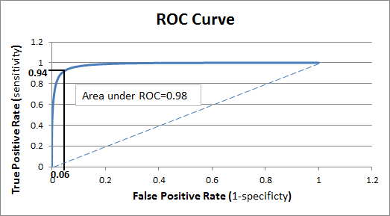

Figure 5.1: ROC curve for predicting the author’s citation pairs.

## Random forest versus other machine learning approaches

Out of four algorithms RF shows the highest accuracy i.e. 94.78% than the other three. It depicts that RF performs better and gives good prediction results than the others. From the Table 5.4the algorithms namely J48, DNN and Nive Bayes have 92.32%, 87.63% and 85.01% accuracy respectively. The 94.78% accuracy means our algorithm will give high results. The remaining 5.22% incorrect results will be displayed. Despite this incorrect results RF is much better than the other algorithms which show 7.68%, 12.37% and 14.99% incorrect results respectively.

Table 5.4: Analysis of algorithm on Knowledge level ORCID Data set

|  |  |  |  |  |  |  |  |
| --- | --- | --- | --- | --- | --- | --- | --- |
| Classification Techniques | Total Number of Instances | Correctly  Classified Instance | Incorrectly  Classified instance | Kappa Statistic | Mean  absolute error | Root mean  squared error | Accuracy |
| RF | 200,777 | 190,291 | 10,486 | 0.87 | 0.09 | 0.20 | 94.78% |
| J48 | 200,777 | 185,616 | 15,161 | 0.80 | 0.12 | 0.26 | 92.32% |
| DNN | 200,777 | 175,949 | 24,828 | 0.69 | 0.18 | 0.31 | 87.63% |
| Naive Bayes Classifier | 200,777 | 170,735 | 30,042 | 0.63 | 0.15 | 0.37 | 85.01% |

The results that have been obtained from these comparative studies show that RF has the highest accuracy. Kappa is near to perfect which renders it as the most capable classifier that can be recommended. Another characteristic of RF is that it has the lowest squared error relative to the other three algorithms and has the least number of incorrect results.

Table5.5shows the detailed accuracy results that have been obtained from the comparison between RF, J48, DNN and Nive Bayes. All measurements proved that RF is performing better than others.True Positive Rate(TPR) or sensitivity in RF is equal to 0.97 for class "No" and the False Positive Rate(FPR) or the specificity is equal to 0.03 for class "Yes". That means 0.03 of negative citation records are incorrectly classified as positive pairs. Accordingly, 0.12 of positive citation pairs are classified as negative citation pairs while they are positive pairs. Precision

shows that RF succeeded to classify 0.96 of negative citation pairs that belong to different authors and 0.93 as positive citation pairs that belongs to the same authors.

ROC curves show that RF performs better than others for both negative and positive citation records. According to PRC area RF succeeded to predict the citations that belong to the same author while PRC area value in J48 , DNN and Nive Bayes are 0.87, 0.83 and 0.81 respectively show that these approaches are overfitting to predict positive citation records.

Table 5.5: Detailed Accuracy by Class

|  |  |  |  |  |  |  |  |  |
| --- | --- | --- | --- | --- | --- | --- | --- | --- |
| Classification  Techniques | TP Rate | FP Rate | Precision | Recall | F-Measure | ROC Area | PRC Area | Class |
| RF | 0.97 | 0.12 | 0.96 | 0.97 | 0.96 | 0.98 | 0.99 | No |
| 0.88 | 0.03 | 0.93 | 0.88 | 0.90 | 0.98 | 0.97 | Yes |
| J48 | 0.96 | 0.17 | 0.94 | 0.96 | 0.95 | 0.94 | 0.96 | No |
| 0.84 | 0.04 | 0.87 | 0.84 | 0.86 | 0.94 | 0.87 | Yes |
| DNN | 0.92 | 0.25 | 0.91 | 0.92 | 0.92 | 0.90 | 0.94 | No |
| 0.75 | 0.08 | 0.80 | 0.75 | 0.77 | 0.90 | 0.83 | Yes |
| Naive Bayes Classifier | 0.90 | 0.27 | 0.90 | 0.90 | 0.90 | 0.90 | 0.95 | No |
| 0.73 | 0.10 | 0.73 | 0.73 | 0.73 | 0.90 | 0.81 | Yes |

The ROC curve in Figure5.2shows that RF achieves the highest area under curve value equal to 0.98 comparing with J48 , DNN and Nive Bayes which were recorded 0.94, 0.90 and

0.90 respectively.

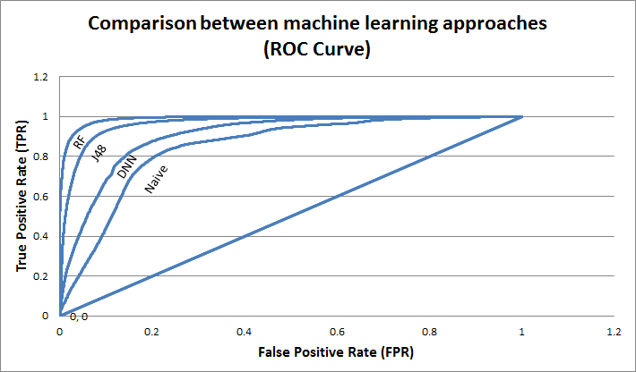

Figure 5.2: Comparison between machine learning approaches (ROC Curve)

## 5.4 Features Ranking and Distance Matrices

The results in Table5.6show the ranking ofDistance Matrices(DM). The InfoGain values ofDMthat we used to find the similarity of coauthors pairs have the highest values between

0.278 and 0.238 excluding NGram algorithm. The InfoGain gives us an indication that coauthors are the most important feature among others in the citation records. Using semantic technique to find the similarity between work title pairs ranked them as the second important feature after

coauthors. Journal title is the third and publishing year is the least important with InfoGain value equal to 0.033. Ranking table also shows that using Jaro Winkler and Levenshtein algorithms to find the similarity of coauthors pairs is worth more than using them with journal title but using Cosine and Jaccard algorithms to find the similarity of journal title pairs is more accurate than using them with coauthors.

Table 5.6: Features Ranking and Distance Matrices

|  |  |  |  |  |
| --- | --- | --- | --- | --- |
| Attributes | DM | Ranked DM | Rank | InfoGain |
| Coauthoers | Jaro Winkler | 2 | 1 | 0.278 |
| Levenshtein | 4 | 2 | 0.256 |
| Cosine | 3 | 3 | 0.252 |
| Jaccard | 1 | 4 | 0.238 |
| NGram | 5 | 14 | 0.024 |
| Work Title | Title2 using collection of dictionaries  (En-Wikipedia, En-PubMedOA, En-BNC) | 14 | 5 | 0.118 |
| Title1 using WordNet dictionary | 13 | 6 | 0.104 |
| Journal Title | Sorensen-Dice | 11 | 7 | 0.060 |
| Cosine | 8 | 8 | 0.059 |
| Jaccard | 6 | 9 | 0.059 |
| Normalized Levenstein | 12 | 10 | 0.045 |
| Jaro Winkler | 7 | 11 | 0.039 |
| NGram | 10 | 12 | 0.035 |
| Levenshtein | 9 | 13 | 0.033 |
| Year | Year | 15 | 15 | 0.002 |

In order to evaluate the importance of each feature, we implemented different experiments using RF with respect to the parameters *Fnum* = 4, *Tnum* = 300 and *Tdepth* = 0. Figure5.3 shows the accuracy that RF achieved by excluding one feature periodically. Removing coauthors will decrease the accuracy to 82.10% which has an impact of 12.9% in eliminating ambiguity in author’s names while removing journal title, work title and publishing year will decrease the accuracy to 89%, 91.44% and 91.80% respectively.

These experiments showed that, coauthors are the most important feature among others in citation records in solving author names disambiguation problem. Journal title is the second feature that has an important impact then work title and finally the publishing year. All of these features have a strong and a promising estimation when they work together in solving the ambiguity of author names.

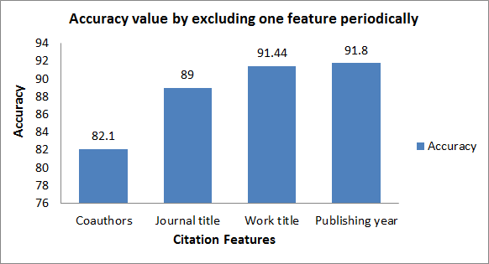

Figure 5.3: Accuracy value by excluding one feature periodically

We excluded the least two values (Year and Levenshtein which used with journal title) according to InfoGain results in Table5.6then we ranked the features again using InfoGain measurement. The results in Table5.7show that coauthors are the most important feature among others, work title is the second and journal title is the third.

Table5.7also shows that using Levenshtein algorithm to find the similarity of coauthors pairs is worth more than using it with journal title but using Cosine and Jaccard algorithms to find the similarity of journal title and coauthors pairs has the same importance.

Table 5.7: Features Ranking and Distance Matrices by excluding the two smallest InfoGain values

|  |  |  |  |  |
| --- | --- | --- | --- | --- |
| Attributes | DM | Ranked DM | Rank | InfoGain |
| Coauthoers | cLeven | 4 | 1 | 0.10074 |
| Work Title | Title2 using collection of dictionaries  (En-Wikipedia, En-PubMedOA, En-BNC) | 13 | 2 | 0.09042 |
| Coauthoers | cJaccard | 1 | 3 | 0.08972 |
| cCosine | 3 | 4 | 0.08615 |
| cJaro | 2 | 5 | 0.05791 |
| Journal Title | jJaccard | 5 | 6 | 0.03345 |
| jCosine | 7 | 7 | 0.03161 |
| Work Title | Title1 using WordNet dictionary | 12 | 8 | 0.02601 |
| Journal Title | jSorensenDice | 10 | 9 | 0.02524 |
| jNormlizedLev | 11 | 10 | 0.01083 |
| jJaro | 6 | 11 | 0.00991 |
| jNGram | 9 | 12 | 0.00817 |
| jLeven | 8 | 13 | 0.00682 |

We evaluate the importance of the features based on the InfoGain ranking results in Table5.7. For this purpose we implemented different experiments using RF with respect to the parameters *Fnum* = 4, *Tnum* = 300 and *Tdepth* = 0. We calculated the accuracy of RF classifier model by validating the predicted results against the testing set using all the distance matrices in Table 5.7that has been ranked by InfoGain measurement for each attribute. Table5.8and5.9show

that we can distinguish whether two citations belong to the same author or not even without the publishing of the year with high accuracy.

Table 5.8: The statistics results in the testing phase

|  |  |  |
| --- | --- | --- |
| # | Test | Result |
| 1 | Correctly Classified Instances | 92.64% |
| 2 | Incorrectly Classified Instances | 7.36% |
| 3 | Kappa statistic | 0.81 |
| 4 | Mean absolute error | 0.11 |
| 5 | Root mean squared error | 0.24 |
| 6 | Total Number of Instances | 200,776 |

Table 5.9: RF detailed accuracy results in testing phase

|  |  |  |  |  |  |  |  |
| --- | --- | --- | --- | --- | --- | --- | --- |
| Class | TP Rate | FP Rate | Precision | Recall | F-Measure | ROC Area | PRC Area |
| no | 0.96 | 0.15 | 0.94 | 0.96 | 0.95 | 0.97 | 0.98 |
| yes | 0.85 | 0.04 | 0.88 | 0.85 | 0.87 | 0.97 | 0.93 |

Figure5.4shows the accuracy that RF achieved by excluding one feature periodically. These experiments showed that coauthors are the most important feature among others in citation records in solving author’s names disambiguation problem. Work title is the second important feature and finally journal title.

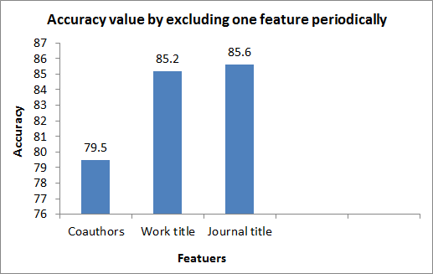

Figure 5.4: Accuracy value by excluding one feature periodically according to InfoGain ranking results

## 5.5 Execution Time

Table5.10represents various data-sets that have been chosen randomly from ORCID database. We extract all citation combinations from each dataset that share LNFI name strings. The execution time that we needed before constructing the machine learning model is divided into

two parts. The former is the time that we need for extracting the features from ORCID database and the latter is the time we need to find the similarity between negative and positive citation pairs.

Table 5.10: Pre-processing time performance

|  |  |  |  |  |  |  |  |
| --- | --- | --- | --- | --- | --- | --- | --- |
| LNFI | Positive  citations | Execution time  per second | Negative  citations | Execution time  per second | Similarity calculation  time per minute | Total execution  time per minute | Total  citations |
| wang, y | 4584 | 225.83 | 1090 | 192.83 | 0.13 | 7.11 | 5674 |
| Ali, M | 4052 | 210.30 | 12804 | 235.59 | 0.42 | 7.86 | 16856 |
| Park, J | 5886 | 210.32 | 43572 | 336.02 | 1.06 | 10.17 | 49458 |
| Chen, Y | 42660 | 311.49 | 208328 | 832.87 | 5.19 | 24.26 | 250988 |
| Liu, Y | 35650 | 305.87 | 267500 | 1001.61 | 5.87 | 27.66 | 303150 |
| Zhang, Y | 120166 | 626.08 | 546518 | 2025.93 | 12.71 | 56.91 | 666684 |
| Li, J | 456362 | 1675.95 | 355850 | 1670.76 | 16.29 | 72.06 | 812212 |
| Kim, J | 330364 | 1159.75 | 850450 | 2603.62 | 22.15 | 84.88 | 1180814 |
| Lee, J | 764264 | 2394.13 | 646306 | 3210.76 | 28.09 | 121.50 | 1410570 |

The quadratic curve in Figure5.5represents the relationship between the total number of extracted citations and the total time that consists of the execution time and the similarity time.

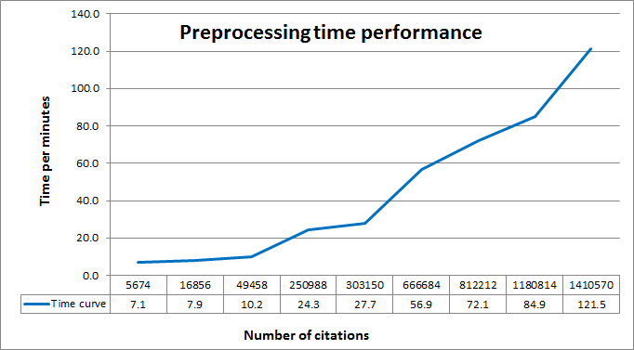

Figure 5.5: Time performance in pre-processing phase

It is also necessary to take into account the time required by the RF learned model to predict unseen samples. For this purpose different testing data sets have been used for evaluating the classification model. For each new test set we calculated the accuracy and the time that RF spent to predict these new citations records. Figure5.6illustrates the time performance of RF classifier for each data set. It describes the execution time required to predict new citation records. We found a non-linear direct proportion between the citation pairs and the execution time and that means more accurate prediction requires more trees, which results in a slower model. We conclude that RF algorithm is fast enough in solving theADproblem based on ORCID citations.

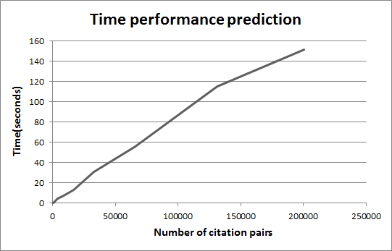

Figure 5.6: Time performance prediction using RF classifier

# Chapter 6

**Conclusion and Future Work**

## Conclusion

We have addressed the problem of author’s names disambiguation for different authors with the same name on ORCID database citations. In order to solve the problem, we introduced a set of methodological steps to exploit the relationships between citations. We have discovered the implied topic-based relationships in citations to influence author names ambiguity and that the accuracy of disambiguation can be significantly improved by looking at citations in ORCID databases or other publications in different databases.

More than one million citation pairs were extracted from ORCID database to construct the negative and positive citation pairs to be used in our experiments. Positive pairs mean that these citations belong to the same author while negative pairs belong to different authors’.

The methodology of solving the problem of author’s names was based on citations that consists of coauthors names, journal title, work title and publishing year. Different distance matrices were used to find the similarity between coauthors and journal title. Semantic knowledge based on collective English language dictionaries was used to find how much two work titles are similar or not. Author who publishes two publications in the same year gives a strong indication that these publications belong to the same author.

We believe that machine learning approaches are the key for solving this problem. Different machine learning algorithms were used to classify the citations record. Our experiment results show that the disambiguation accuracy improved to 94.78% by using RF classifier while Nive Bayes, J48 and DNN have 85.01%,92.32% and 87.63% accuracy respectively.

Of the four basic attributes, the coauthor attribute provides the most useful information for disambiguation, and journal title is slightly better than work title and the year of publishing. In addition, disambiguation information derived by Jaro Winkler, Levenshtein, Cosine and Jaccard metric contains less noise in finding the similarity of coauthors than NGram. Sorensen-Dice, Cosine, Jaccard and Normalized Levenstein metric have less noise in finding the similarity of journal titles.

Also, we conclude that removing the year of publishing will not negatively affect the result

*Conclusion and Future Work*

of disambiguation accuracy. Almost, Rf achieved 93% accuracy and the ROC curve reflects the appropriate accuracy of 97% in predicting negative and positive author’s citation pairs.

The Web application, which was designed based on our vision to solve the problem of ambiguity in authors’ names, is a sure indication of the usefulness of the methodology of our study that has the ability to classify new citations outside the boundaries of ORCID databases.

In summary, our contribution in grouping citation pairs of the same author into the correct class is more accurate and proposes a useful solution for name disambiguation improvements.

## Future Work

Different experiments have been left for the future due to lack of time i.e. the experiment requiring even months to finish. Future work concerns deeper analysis of particular mechanisms, new proposals to try different methods. There are some ideas that I would have liked to try during the description and the development of the functionality of solving author’s names disambiguation problem.

This thesis has been mainly focused on the use of ORCID citations for author’s names matching, and most of the mechanisms used are focused on answering the question whether two citations belong to the same author or not. The following points among the points that we have been achieved are left outside the scope of this thesis

* + - Filtration ORCID identifiers in which each author must have a unique and distinct ORCID ID. This assumption will help ORCID to:
      * Achieve the one-to-one relationship between ORCDI ID and author name.
      * Save more space by removing the duplication records.
      * Solve the problem of name disambiguation and achieve more accuracy.
    - Updating the work activity records for each author will help ORCID to:
      * Add a new external citation to the appropriate author records.
      * Control over profile information from third-party profiles.
    - Trying other existent larger databases, such as DBLP, ACM Digital Library and Citeseer.
    - Author citation information, the key input to our system, is still imperfect due to some information loss. Considering the variety of cultural backgrounds of ORCID citation authors, a better system is necessary to recover information lost during the data collection stages such as email and affiliation.

# Appendix A Web-Application

FigureA.1illustrates the *matching* and *not matching* process for any citation pairs. It starts by checking whether two authors belong to the LNFI criteria or not. If they are different then the results will not match. If they belong to the LNFI criteria then the process will continue to calculate the similarity of the coauthors, journal title, work title and the year of publications. The application will pass the similarity vector to the trained RF learning model which gives us an indication whether the two citations records are related to the same author or not. Different java classes have been used in the application as follow:

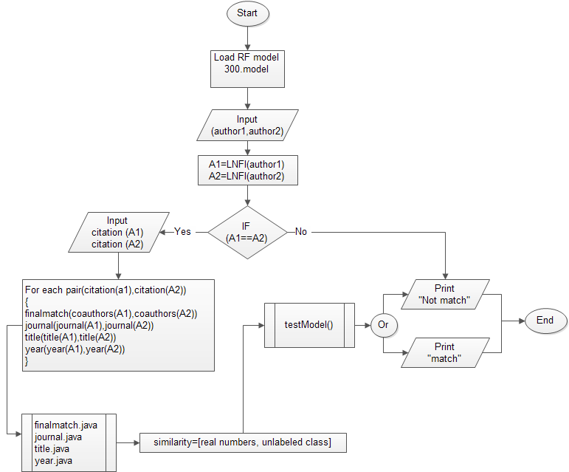

Figure A.1: Matching and not matching web-application process

The *processRequest* method is used to declare the desired variables and the required methods that we use to perform the calculation process.

protectedvoidprocessRequest(HttpServletRequest request, HttpServletResponse response)

throwsServletException, IOException { response.setContentType("text/html;charset=UTF-8"); DecimalFormat formatter =newDecimalFormat("#.##"); doublej[] = {0, 0, 0, 0, 0, 0, 0};

doublec[] = {0, 0, 0, 0, 0}; String finalscore[] = {""}; String prediction ="";

PrintWriter out = response.getWriter(); String auhtor1firstname =

request.getParameter("authoronefirstname").toString(); String author1lastname =

request.getParameter("authoronelastname").toString(); String author2firstname =

request.getParameter("authortwofirstname").toString(); String author2lastname =

request.getParameter("authortwolastname").toString(); String fullname ="["+ auhtor1firstname +""+

author1lastname +"]<==>["+ author2firstname +""+ author2lastname +"]is:";

inty1 =

Integer.parseInt(request.getParameter("firstyear").toString()); inty2 =

Integer.parseInt(request.getParameter("secondyear").toString()); String c1 = request.getParameter("co1").toString();

String c2 = request.getParameter("co2").toString(); String title1 =

request.getParameter("authoronetitle").toString(); String title2 =

request.getParameter("authortwotitle").toString(); String journal1 =

request.getParameter("authoronejournal").toString(); String journal2 =

request.getParameter("authortwojournal").toString(); doubleyearvalue = 0;

doubleworktitle = 0;

doubleworktitle2 = 0; if(author1lastname.equals(author2lastname) &&

auhtor1firstname.substring(0, 1).equals(author2firstname.substring(0, 1))) { yearvalue = years(y1, y2);

worktitle = maintitle(title1, title2); worktitle2 = smain(title1, title2);

j = journal.journalmatch(journal1, journal2); c = finalmatch.comatch(c1, c2); finalscore[0] = formatter.format(c[0]) +","+

formatter.format(c[1]) +","+ formatter.format(c[2]) + ","

+ formatter.format(c[3]) +","+ formatter.format(c[4]) +","

+ formatter.format(j[0]) +","+ formatter.format(j[1]) +","+ formatter.format(j[2]) +","

+ formatter.format(j[3]) +","+ formatter.format(j[4]) +","+ formatter.format(j[5]) +","

+ formatter.format(j[6]) +","

+ formatter.format(worktitle) +","+ formatter.format(worktitle2) +","

+ formatter.format(yearvalue) +","+"?";

}else{

finalscore[0] = 0 +","+ 0 +","+ 0 +","

|  |  |  |  |  |  |
| --- | --- | --- | --- | --- | --- |
| + | 0 | +","+ | 0 | +"," |  |
| + | 0 | +","+ | 0 | +","+ | 0 +"," |
| + | 0 | +","+ | 0 | +","+ | 0 +"," |
| + | 0 | +"," |  |  |  |
| + | 0 | +","+ | 0 | +"," |  |

+ 0 +","+"?";

}

writeCsvFile(finalscore[0]); unlabel(fullname); out.println("<html>"); out.println("<head>");

out.println("<title>ServletGreetingServlet</title>"); out.println("</head>");

out.println("<body>");

out.println("<p>Welcome"+ formatter.format(c[0]) +","+ formatter.format(c[1]) +","+ formatter.format(c[2]) +","

+ formatter.format(c[3]) +","+ formatter.format(c[4])

+","

+ formatter.format(j[0]) +","+ formatter.format(j[1])

+","+ formatter.format(j[2]) +","

+ formatter.format(j[3]) +","+ formatter.format(j[4])

+","+ formatter.format(j[5]) +","

+ formatter.format(j[6]) +","

+ formatter.format(worktitle) +","+ formatter.format(worktitle2) +","

+ formatter.format(yearvalue) +","+"?"+"</p><br>"); out.println(readfile() +"</body>"); out.println("</html>");

out.close();

}

The following *finalmatch* class is used to calculate the coauthors similarity scores

publicclassfinalmatch { publicstaticJaccard j; publicstaticJaroWinkler jw; publicstaticOptimalStringAlignment OP; publicstaticLevenshtein we; publicstaticSorensenDice so; publicstaticNGram ng; publicstaticCosine co; publicstaticDamerau dam; publicstaticNormalizedLevenshtein Norl;

publicstaticString normlizetext(String w) {

w = w.replaceAll("\\s+$","");//rightRemoved w = w.replaceAll("^\\s+","");//leftRemoved w = w.replace(",","");

w = w.toLowerCase();

//System.out.print(w); returnw;

}

publicstaticdoublejaccardcomp(String w1, String w2) { doubler = 0;

r = (double) (j.similarity(w1, w2)); returnr;

}

publicstaticdoublejarocomp(String w1, String w2) { doubler = 0;

r = (double) (jw.similarity(w1, w2));

returnr;

}

publicstaticdoubleCosinecomp(String w1, String w2) { doubler = 0;

r = (double) (co.similarity(w1, w2)); returnr;

}

publicstaticdoubleLevencomp(String w1, String w2) { doubler = 0;

r = (double) (Norl.similarity(w1, w2)); returnr;

}

publicstaticdoubleDameraucomp(String w1, String w2) { doubler = 0;

r = (double) (ng.distance(w1, w2)); returnr;

}

publicstaticdoubleprintgridarray(doublea[][],intxlen,int ylen, String str) {

intfullmatchcount = 0;

intpartialcount = 0;

doublepartialsum = 0;

doubleresult = 0;

doublepartialweight = 0;

doublefullmatchweight = 0;

doublef1 = 0, f2 = 0;

intprint = 0;//1todesplaythedetailsand0thefinal results

doublepweight = .75; if(print == 1) {

System.out.printf("\n=========\n"); System.out.printf("\t\t%s\t\t", str); System.out.printf("\n \n");

}

for(intx = 0; x <= xlen; x++) { for(inty = 0; y <= ylen; y++) {

if(print == 1) { System.out.printf("%.2f", a[x][y]);

}

if(a[x][y] == 1) { fullmatchcount++;

}

if(a[x][y] != 1 && a[x][y] > pweight) { partialsum = partialsum + (a[x][y] - pweight); partialcount++;

}

}

if(print == 1) { System.out.printf("\n");

}

}

if(fullmatchcount == 0 && partialcount == 0) { f1 = 0;

f2 = 0;

fullmatchweight = f1; partialweight = f2;

}elseif(fullmatchcount == 0 && partialcount > 0) { f1 = 0;

f2 = 0.5;

fullmatchweight = f1;

partialweight = ((partialsum / partialcount));

}elseif(fullmatchcount == 1 && partialcount > 0) { f1 = 0.5;

f2 = 0.5;

fullmatchweight = f1;

partialweight = ((partialsum / partialcount));

}elseif(fullmatchcount == 1 && partialcount == 0) { f1 = 0.5;

f2 = 0;

fullmatchweight = f1; partialweight = f2;

}elseif(fullmatchcount == 2 && partialcount > 0) { f1 = 0.75;

f2 = 0.25;

fullmatchweight = f1;

partialweight = ((partialsum / partialcount));

}elseif(fullmatchcount == 2 && partialcount == 0) { f1 = 0.75;

f2 = 0;

fullmatchweight = f1;

partialweight = f2;

}elseif(fullmatchcount > 2) { f1 = 1;

f2 = 0;

fullmatchweight = f1; partialweight = f2;

}

result = fullmatchweight + partialweight; if(print == 1) {

System.out.printf("\n \n");

System.out.printf("f1:(%.2f)\tFullmatchcount:(%d)

,\t\tFullmatchweight:%.2f", f1, fullmatchcount, fullmatchweight);

System.out.printf("\nf2:(%.2f)\tPartialsum(%.2f),partial count:(%d),PartialWeight:%.2f", f2, partialsum, partialcount, partialweight);

System.out.printf("\n\t\t\t\t\t\tResult:\t%.2f\t", result); System.out.printf("\n=================\n");

}

returnresult;

}

publicstaticdouble[] comatch(String s1, String s2) { inti;

jw =newJaroWinkler(); j =newJaccard(1);

OP =newOptimalStringAlignment(); co =newCosine();

ng =newNGram();

we =newLevenshtein(); so =newSorensenDice();

Norl =newNormalizedLevenshtein(); dam =newDamerau();

doubleco[] = {0, 0, 0, 0, 0}; String beforew1 ="";

String afterw1 =""; String beforew2 =""; String afterw2 =""; String secondS =""; String firstS =""; doublec1 = 0.0;

doublec2 = 0.0;

doublec3 = 0;

doublec4 = 0;

doublec5 = 0;

String[] s1arry = s1.split(";");

String[] s2arry = s2.split(";");

doubleoutgrid[][] =newdouble[s1arry.length][s2arry.length]; doubleoutgrid1[][] =newdouble[s1arry.length][s2arry.length]; doubleoutgrid2[][] =newdouble[s1arry.length][s2arry.length]; doubleoutgrid3[][] =newdouble[s1arry.length][s2arry.length]; doubleoutgrid4[][] =newdouble[s1arry.length][s2arry.length]; intx = 0;

inty = 0;

if(s1.isEmpty() || s2.isEmpty()) {

}else{

for(String w1 : s1arry) { y = 0;

w1 = normlizetext(w1); if(w1.contains(",")) {

beforew1 = w1.split(",")[0];

afterw1 = w1.split(",")[w1.split(",").length - 1]; firstS = beforew1.concat("").concat(afterw1);

}else{

firstS = w1;

}

for(String w2 : s2arry) { w2 = normlizetext(w2); if(w2.contains(",")) {

beforew2 = w2.split(",")[0];

afterw2 = w2.split(",")[w2.split(",").length - 1]; secondS = beforew2.concat("").concat(afterw2);

}else{

secondS = w2;

}

c1 = jaccardcomp(w1, w2); c2 = jarocomp(w1, w2); c3 = Cosinecomp(w1, w2); c4 = Levencomp(w1, w2); c5 = Dameraucomp(w1, w2); outgrid[x][y] = c1; outgrid1[x][y] = c2; outgrid2[x][y] = c3; outgrid3[x][y] = c4; outgrid4[x][y] = c5;

y++;

}

x++;

}

co[0] = printgridarray(outgrid, x - 1, y - 1,"Jacard"); co[1] = printgridarray(outgrid1, x - 1, y - 1,"Jaro"); co[2] = printgridarray(outgrid2, x - 1, y - 1,"Cosine"); co[3] = printgridarray(outgrid3, x - 1, y - 1,"Leven"); co[4] = printgridarray(outgrid4, x - 1, y - 1,"Damerau");

}

returnco;

}

}

The following *journal* class is used to calculate the journal titles similarity scores

publicclassjournal { publicstaticJaccard j; publicstaticJaroWinkler jw;

publicstaticOptimalStringAlignment OP; publicstaticLevenshtein we; publicstaticSorensenDice so; publicstaticNGram ng; publicstaticCosine co; publicstaticDamerau dam; publicstaticNormalizedLevenshtein Norl; publicstaticWeightedLevenshtein wlv;

publicstaticdoublejaccardcomp(String w1, String w2) { doubler = 0;

r = (double) (j.similarity(w1, w2)); returnr;

}

publicstaticdoublejarocomp(String w1, String w2) { doubler = 0;

r = (double) (jw.similarity(w1, w2)); returnr;

}

publicstaticdoubleCosinecomp(String w1, String w2) { doubler = 0;

r = (double) (co.similarity(w1, w2)); returnr;

}

publicstaticdoubleLevencomp(String w1, String w2) { doubler = 0;

r = (double) (we.distance(w1, w2)); returnr;

}

publicstaticdoubleDameraucomp(String w1, String w2) { doubler = 0;

r = (double) (dam.distance(w1, w2)); returnr;

}

publicstaticdoubleOPcomp(String w1, String w2) { doubler = 0;

r = (double) (OP.distance(w1, w2)); returnr;

}

publicstaticdoubleNgramcomp(String w1, String w2) { doubler = 0;

r = (double) (ng.distance(w1, w2)); returnr;

}

publicstaticdoubleSorensenDicecomp(String w1, String w2) { doubler = 0;

r = (double) (so.distance(w1, w2)); returnr;

}

publicstaticdoubleNormalcomp(String w1, String w2) { doubler = 0;

r = (double) (Norl.distance(w1, w2)); returnr;

}

publicstaticdoublewlvcomp(String w1, String w2) { doubler = 0;

r = (double) (wlv.distance(w1, w2)); returnr;

}

publicstaticdouble[] journalmatch(String string1, String string2) {

j =newJaccard(4);

jw =newJaroWinkler(4); co =newCosine(4);

we =newLevenshtein(); dam =newDamerau();

OP =newOptimalStringAlignment(); ng =newNGram(4);

so =newSorensenDice();

Norl =newNormalizedLevenshtein(); doublej[] = {0, 0, 0, 0, 0, 0, 0};

inti = 0;

doubles1, s2, s3, s4, s5, s6, s7, s8, s9 = 0; DecimalFormat decimalFormat =newDecimalFormat("#.00"); s1 = jaccardcomp(string1, string2);//jaccrd

s2 = jarocomp(string1, string2);//jaro

s3 = Cosinecomp(string1, string2);//Cosinecomp s4 = Levencomp(string1, string2);//Levencomp

s5 = Dameraucomp(string1, string2);//Dameraucomp

s6 = OPcomp(string1, string2);//OptimalStringAlignment s7 = Ngramcomp(string1, string2);//NGram

s8 = SorensenDicecomp(string1, string2);//SorensenDice s9 = Normalcomp(string1, string2);//NormalizedLevenshtein j[0] = s1;

j[1] = s2;

j[2] = s3;

j[3] = s4;

j[4] = s7;

j[5] = s8;

j[6] = s9;

returnj;

}

}

The following *title* class is used to calculate the work titles similarity score using collection of dictionaries.

publicclasstitle { String a =""; String b ="";

publicCompare(String a, String b) { this.a = a.toLowerCase(); this.b = b.toLowerCase();

}

publicdoublegetResult() {

StringTokenizer ta =newStringTokenizer(a, "~!@#$%^&*()_-=+‘[]{}:\"\\|;’<>?,./"); StringTokenizer tb =newStringTokenizer(b,

"~!@#$%^&*()_-=+‘[]{}:\"\\|;’<>?,./"); if(ta.countTokens() == 1) {

File f =new File("C:\\MyFirstServlet1\\semantics\\src\\collocation_dict\\"

+ Character.toString(a.charAt(0)) +"\\"+ Character.toString(a.charAt(1)) +"\\"+ a +".txt");

if(!f.exists()) { return-1;

}

}

if(tb.countTokens() == 1) { File f =new

File("C:\\MyFirstServlet1\\semantics\\src\\collocation_dict\\"

+ Character.toString(b.charAt(0)) +"\\"+ Character.toString(b.charAt(1)) +"\\"+ b +".txt");

if(!f.exists()) { return-1;

}

}

String aa =""; String bb ="";

while(ta.hasMoreTokens()) { String g = ta.nextToken(); String add = read(g); if(add.equals("")) {

aa = aa +""+ g;

//Jumah

//System.out.print(aa);

}else{

aa = aa +""+ read(g);

}

}

while(tb.hasMoreTokens()) { String g = tb.nextToken(); String add = read(g); if(add.equals("")) {

bb = bb +""+ g;

//Jumah

//System.out.print(bb);

}else{

bb = bb +""+ read(g);

}

}

try{

TermVectorStorage storage =newHashMapTermVectorStorage(); VectorClassifier vc =newVectorClassifier(storage); vc.teachMatch("category", aa);

doubleresult = vc.classify("category", bb); returnresult;

}catch(Exception e) { return-1;

}

}

privateString read(String g) { try{

String filename = ("C:\\MyFirstServlet1\\semantics\\src\\collocation_dict\\"

+ Character.toString(g.charAt(0)) +"\\"+ Character.toString(g.charAt(1)) +"\\"+ g +".txt");

File f =newFile(filename); if(f.exists()) {

BufferedReader bread =newBufferedReader(new FileReader(filename));

String rt = bread.readLine(); bread.close();

returnrt;

}else{

return"";

}

}catch(Exception e) { return"";

}

}

}

The following *years* method is used to calculate the year of publications similarity score.

publicstaticdoubleyears(intyear1,intyear2) { intresult = 0;

doublefinalresult = 0;

result = Math.abs(year2 - year1); if(result == 0) {

finalresult = 1;

}else{

finalresult = (double) 1 / result;

}

returnfinalresult;

}

The following *loadModel* method is used to load RF trained method.

publicstaticRandomForest loadModel(String fileName) { try{

intbufferSize = 16 * 1024;

ObjectInputStream in =newObjectInputStream(new BufferedInputStream(newFileInputStream(fileName), bufferSize));

Object tmp = in.readObject();

RandomForest classifier = (RandomForest) tmp; in.close();

loadfile ="=====Loadedmodel:"+ fileName +"====="; returnclassifier;

}

catch(Exception e) {

loadfile ="Problemfoundwhenreading:"+ fileName;

}

returnnull;

}

The following *unlabel* method is used to predict the unseen citation pairs.

publicvoidunlabel(String name) {

unlabeledtest ="C:\\MyFirstServlet1\\test\\test.arff"; String unclasses ="";

String MoM =""; String y ="yes"; String n ="no"; String score =""; try{

Instances unlabeled =newInstances(newBufferedReader(new FileReader(unlabeledtest)));

unlabeled.setClassIndex(unlabeled.numAttributes() - 1); Instances labeled =newInstances(unlabeled);

for(inti = 0; i < unlabeled.numInstances(); i++) { doubleclsLabel =

randomForest.classifyInstance(unlabeled.instance(i));

double[] prediction = randomForest.distributionForInstance(unlabeled.instance(i));

labeled.instance(i).setClassValue(clsLabel); String ClassLabel;

ClassLabel = unlabeled.classAttribute().value((int) clsLabel);

unclasses ="\n"+ unclasses + (i + 1) +"\t"+ ClassLabel;

if(ClassLabel.equals(y)) { MoM ="Mach";

}elseif(ClassLabel.equals(n)) { MoM ="NotMatch";

}

score = Arrays.toString(prediction);

}

writeoutput(name, MoM, score); BufferedWriter writer =newBufferedWriter(

new

FileWriter("C:\\MyFirstServlet1\\unlabel\\labeled.arff")); writer.write(labeled.toString());

writer.newLine(); writer.flush(); writer.close();

}catch(Exception e) { System.out.println("Problemfoundwhenwritting:"+

unlabeledtest);

}

}

FigureA.2is a graphical user interface web-application used to check whether two authors’ share the same family name and the first initial of the given name. The application window is split into two sub-windows one on the right and one on the left. Each one represents an author meta-data that consist of author LNFI, coauthors, journal title and work title. All records are required during data entry. The *Submit* button at the top left corner is used to printout the results of the application and the *About* button is used to printout the instructions about how to use the application. The results are displayed at the bottom of the browser screen.

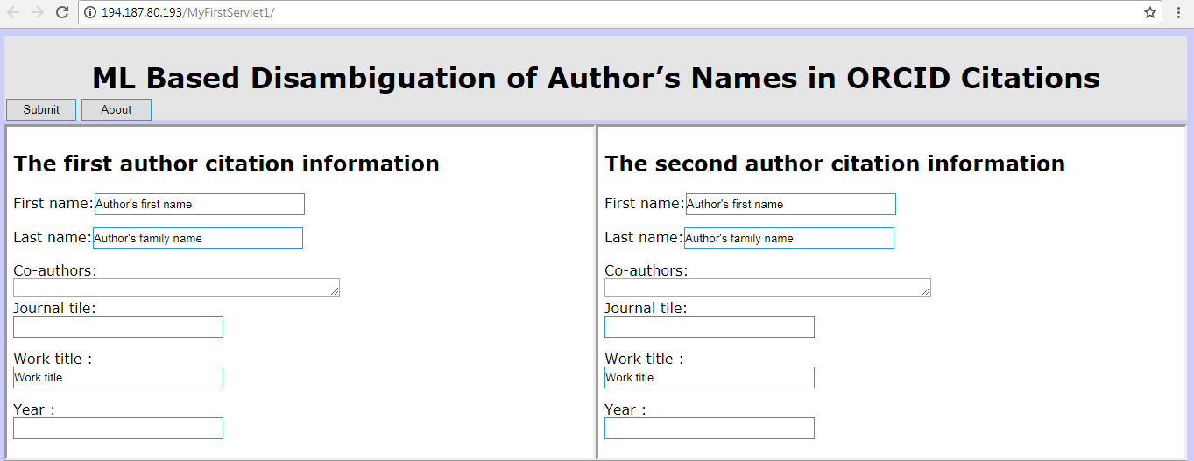

Figure A.2: ML Based Disambiguation of Author’s Names in ORCID Citations Application

# Bibliography

1. Orcid organization. Researcher profile.
2. Dongwon Lee, Jaewoo Kang, Prasenjit Mitra, C Lee Giles, and Byung-Won On. Are your citations clean. *Communications of the ACM*, 50(12):33–38, 2007.
3. Kai-Hsiang Yang, Hsin-Tsung Peng, Jian-Yi Jiang, Hahn-Ming Lee, and Jan-Ming Ho. Author name disambiguation for citations using topic and web correlation. *Research and advanced technology for digital libraries*, pages 185–196, 2008.
4. Neil R Smalheiser and Vetle I Torvik. Author name disambiguation. *Annual Review of Information Science and Technology*, pages 5–34, 2009.
5. George Papadakis and Georgios Paliouras. Mycites: An intelligent information system for maintaining citations. *Artificial Intelligence: Theories, Models and Applications*, pages 371–376, 2008.
6. Prasenjit Mitra, Jaewoo Kang, Dongwon Lee, and Byung-won On. Comparative study of name disambiguation problem using a scalable blocking-based framework. In *Digital Libraries, 2005. JCDL’05. Proceedings of the 5th ACM/IEEE-CS Joint Conference on*, pages 344–353. IEEE, 2005.
7. Jan Youtie, Stephen Carley, Alan L Porter, and Philip Shapira. Tracking researchers and their outputs: new insights from orcids. *Scientometrics*, 113(1):437–453, 2017.
8. Laurel L Haak, Martin Fenner, Laura Paglione, Ed Pentz, and Howard Ratner. Orcid: a system to uniquely identify researchers. *Learned Publishing*, 25(4):259–264, 2012.
9. Hui Han, Lee Giles, Hongyuan Zha, Cheng Li, and Kostas Tsioutsiouliklis. Two supervised learning approaches for name disambiguation in author citations. In *Digital Libraries, 2004. Proceedings of the 2004 joint ACM/IEEE conference on*, pages 296–305. IEEE, 2004.
10. Hui Han, Hongyuan Zha, and C Lee Giles. Name disambiguation in author citations using a k-way spectral clustering method. 2005.
11. Mark Hall, Eibe Frank, Geoffrey Holmes, Bernhard Pfahringer, Peter Reutemann, and Ian H Witten. The weka data mining software: an update. *ACM SIGKDD explorations newsletter*, 11(1):10–18, 2009.
12. Ian H Witten, Eibe Frank, Mark A Hall, and Christopher J Pal. *Data Mining: Practical machine learning tools and techniques*. Morgan Kaufmann, 2016.
13. Victor Francisco Rodriguez-Galiano, Bardan Ghimire, John Rogan, Mario Chica-Olmo, and Juan Pedro Rigol-Sanchez. An assessment of the effectiveness of a random forest classifier for land-cover classification. *ISPRS Journal of Photogrammetry and Remote Sensing*, 67:93–104, 2012.
14. Yan-Min Luo, De-Tian Huang, Pei-Zhong Liu, and Hsuan-Ming Feng. An novel ran- dom forests and its application to the classification of mangroves remote sensing image. *Multimedia Tools and Applications*, 75(16):9707–9722, 2016.
15. Pucktada Treeratpituk and C Lee Giles. Disambiguating authors in academic publications using random forests. In *Proceedings of the 9th ACM/IEEE-CS joint conference on Digital libraries*, pages 39–48. ACM, 2009.
16. Thais Mayumi Oshiro, Pedro Santoro Perez, and Jose Augusto Baranauskas. How many trees in a random forest? In *International Workshop on Machine Learning and Data Mining in Pattern Recognition*, pages 154–168. Springer, 2012.
17. Leo Breiman. Random forests. *Machine learning*, 45(1):5–32, 2001.
18. Jiliang Tang, Salem Alelyani, and Huan Liu. Feature selection for classification: A review.

*Data Classification: Algorithms and Applications*, page 37, 2014.

1. Lei Yu and Huan Liu. Feature selection for high-dimensional data: A fast correlation-based filter solution. In *Proceedings of the 20th international conference on machine learning (ICML-03)*, pages 856–863, 2003.
2. Payam Refaeilzadeh, Lei Tang, and Huan Liu. Cross-validation. In *Encyclopedia of database systems*, pages 532–538. Springer, 2009.
3. Jose G Moreno-Torres, Josea Saez, and Francisco Herrera. Study on the impact of partition- induced dataset shift on *k*-fold cross-validation. *IEEE Transactions on Neural Networks and Learning Systems*, 23(8):1304–1312, 2012.
4. Tom Fawcett. An introduction to roc analysis. *Pattern recognition letters*, 27(8):861–874, 2006.
5. Kevin Markham. Simple guide to confusion matrix terminology. *Data School [online]*, 2014.
6. Yutaka Sasaki et al. The truth of the f-measure. *Teach Tutor mater*, 1(5), 2007.
7. Jeff Jenness and J Judson Wynne. Cohens kappa and classification table metrics 2.0: An arcview 3. x extension for accuracy assessment of spatially explicit models. *Open-File Report OF 2005-1363. Flagstaff, AZ: US Geological Survey, Southwest Biological Science Center. 86 p*, 2005.
8. Javad Zahiri, Joseph Hannon Bozorgmehr, and Ali Masoudi-Nejad. Computational predic- tion of protein–protein interaction networks: algorithms and resources. *Current genomics*, 14(6):397–414, 2013.
9. Jerome Euzenat and Pavel Shvaiko. Basic similarity measures. In *Ontology Matching*, pages 85–120. Springer, 2013.
10. Felix Naumann. Similarity measures. *Information Systems*, 2013.
11. Tin Huynh, Kiem Hoang, Tien Do, and Duc Huynh. Vietnamese author name disam- biguation for integrating publications from heterogeneous sources. In *ACIIDS (1)*, pages 226–235, 2013.
12. Allen Taylor. *Semantics For Dummies*. John Wiley & Sons, Inc, 111 River St, 2015.
13. Tomas Ptacek. *Master Thesis Advanced Methods for Sentence Semantic Similarity*. Pilsen, 2012.
14. Christopher D Manning, Prabhakar Raghavan, and Hinrich Schutze. Introduction to information retrieval cambridge university press, 2008. *Ch*, 20:405–416.
15. Vimala Balakrishnan and Ethel Lloyd-Yemoh. Stemming and lemmatization: a comparison of retrieval performances. *Lecture Notes on Software Engineering*, 2(3):262, 2014.
16. Pantulkar Sravanthi and DRB Srinivasu. Semantic similarity between sentences. 2017.
17. Peter Kolb. Experiments on the difference between semantic similarity and relatedness. pages 81–88, 2009.
18. Philipp Koehn. Europarl: A parallel corpus for statistical machine translation. In *MT summit*, volume 5, pages 79–86, 2005.
19. Agazi Mekonnen and Shamsi Abdullayev. Topic modeling and clustering for analysis of road traffic accidents. *Department of Applied Mechanics, Chalmers University of Technology*, pages 4–64, 2017.
20. Wilbert Jan Heeringa. *Measuring dialect pronunciation differences using Levenshtein distance*. PhD thesis, University Library Groningen][Host], 2004.
21. Vladimir I Levenshtein. Binary codes capable of correcting deletions, insertions, and reversals. In *Soviet physics doklady*, volume 10, pages 707–710, 1966.
22. Jennifer Daniels, Doug Nye, and Gongzhu Hu. Cluster analysis for commonalities between words of different languages. In *Applied Computing and Information Technology*, pages 71–84. Springer, 2016.
23. Manop Phankokkruad. Efficient similarity measurement by the combination of distance algorithms to identify the duplication relativity. In *International Conference on Computer and Information Science*, pages 219–232. Springer, 2017.
24. Wael H Gomaa and Aly A Fahmy. A survey of text similarity approaches. *International Journal of Computer Applications*, 68(13), 2013.
25. Jure Leskovec, Anand Rajaraman, and Jeffrey D Ullman. Mining of massive datasets, 2014.
26. Baoli Li and Liping Han. Distance weighted cosine similarity measure for text classification. In *International Conference on Intelligent Data Engineering and Automated Learning*, pages 611–618. Springer, 2013.
27. Abinash Tripathy, Ankit Agrawal, and Santanu Kumar Rath. Classification of sentiment reviews using n-gram machine learning approach. *Expert Systems with Applications*, 57:117–126, 2016.
28. Abdulla Ali. Textual similarity. *Technical University of Denmark*, 2011.
29. S Elliott. Survey of author name disambiguation: 2004 to 2010 [j/ol]. *Library Philosophy & Practice.* [*http://digitalcommons.*](http://digitalcommons/) *unl. edu/cgi/viewcontent. cgi*, 2015.
30. Hung Nghiep Tran, Tin Huynh, and Tien Do. Author name disambiguation by using deep neural network. In *Asian Conference on Intelligent Information and Database Systems*, pages 123–132. Springer, 2014.
31. Andreas Strotmann and Dangzhi Zhao. Author name disambiguation: What difference does it make in author-based citation analysis? *Journal of the Association for Information Science and Technology*, 63(9):1820–1833, 2012.
32. Duncan M McRae-Spencer and Nigel R Shadbolt. Also by the same author: Aktiveauthor, a citation graph approach to name disambiguation. In *Proceedings of the 6th ACM/IEEE-CS joint conference on Digital libraries*, pages 53–54. ACM, 2006.
33. Anderson A Ferreira, Marcos André Gonçalves, and Alberto HF Laender. A brief survey of automatic methods for author name disambiguation. *SIGMOD Record*, 41(2):15, 2012.
34. Kyohei Atarashi, Satoshi Oyama, Masahito Kurihara, and Kazune Furudo. A deep neural network for pairwise classification: Enabling feature conjunctions and ensuring symmetry. In *Pacific-Asia Conference on Knowledge Discovery and Data Mining*, pages 83–95. Springer, 2017.
35. Bart Thijs, Koenraad Debackere, and Wolfgang Glänzel. Improved author profiling through the use of citation classes. *Scientometrics*, 111(2):829–839, 2017.
36. Denilson Alves Pereira, Berthier Ribeiro-Neto, Nivio Ziviani, Alberto HF Laender, Mar- cos André Gonçalves, and Anderson A Ferreira. Using web information for author name disambiguation. In *Proceedings of the 9th ACM/IEEE-CS joint conference on Digital libraries*, pages 49–58. ACM, 2009.
37. Ibrahim M. Qdemat. A heuristic-based approach for author name disambiguation. pages 2–19, 2017.
38. Shahd Zeiad Ewawi. A rule-based clustering method for author name disambiguation in the domain of publications. pages 2–25, January, 2017.
39. Jerome P Kassirer and Marcia Angell. Redundant publication: A reminder, 1995.